**Assignment 3**   
**Secure DevOps Pipeline for Application Deployment**

Unit: ISEC6000 Secure DevOps   
Name: Ming Yong Tan   
Student ID: 21920794   
Github repo link:   
1. <https://github.com/mingyongtan/task1-2-3_devsops_21920794/tree/main>

2. <https://github.com/mingyongtan/express-es6-sample>4. <https://github.com/mingyongtan/threatdragon_devsops_21920794>

Task 1 — Docker & Compose 3

1.1 Install Docker Engine + Compose 3

1.2 Restrict Docker to sudo only 5

1.3 Short Security Summary (why this restriction matters) 5

Task 2: Deploy Portainer for Docker Management 7

2.1 Download and inspect compose.yaml file. 7

2.2 Valid restart options 7

2.3 Deploy Portainer stack 7

2.4 Access log monitoring 11

Task 3: Setup a NextCloud stack with PostgreSQL 14

3.1 Inspect compose.yaml and explain expose: 14

3.2 Deploy the Nextcloud + PostgreSQL stack 15

3.3 CLI management 18

3.4 Ensure DB starts before Nextcloud 24

Task 4: Container Security Scanning with Clair 27

4.1 Install PostgreSQL + Clair via Docker Compose 27

4.2 Perform Container Security Scanning 35

Task 5: AWS CodePipeline for Node.js 46

1. Stage 1: Source 49

2. Stage 2: Build 52

3. Stage 3: Test 56

4. Stage 4 Delopy 59

Task 6: Threat Modelling using STRIDE 75

1. Create a New Model: 75

2. Map the System Components: 76

3. Identify Threats Using STRIDE: 78

4. Document and Mitigate Threats: 81

# Task 1 — Docker & Compose

## 1.1 Install Docker Engine + Compose

Quick Folder setup for the assignment. All folders given from the assessment are already unzipped and moved to the folder below.

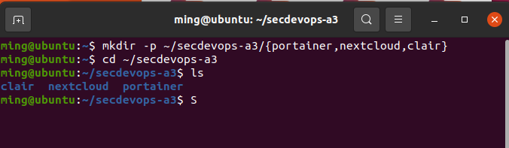

Delete any existing container and update package before install docker

sudo apt-get update -y

sudo apt-get install -y ca-certificates curl gnupg lsb-release

sudo install -m 0755 -d /etc/apt/keyrings

curl -fsSL <https://download.docker.com/linux/ubuntu/gpg> | sudo gpg --dearmor -o /etc/apt/keyrings/docker.gpg

echo "deb [arch=$(dpkg --print-architecture) signed-by=/etc/apt/keyrings/docker.gpg] <https://download.docker.com/linux/ubuntu> $(. /etc/os-release && echo $UBUNTU_CODENAME) stable" | sudo tee /etc/apt/sources.list.d/docker.list > /dev/null

sudo apt-get update -y

sudo apt-get install -y docker-ce docker-ce-cli containerd.io docker-buildx-plugin docker-compose-plugin

# Versions for evidence

docker --version

docker compose version

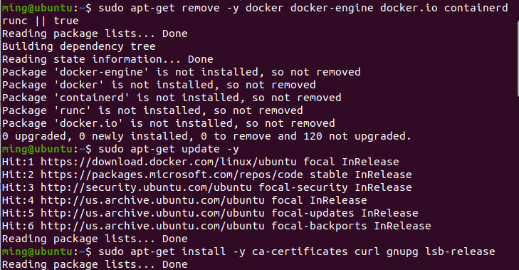

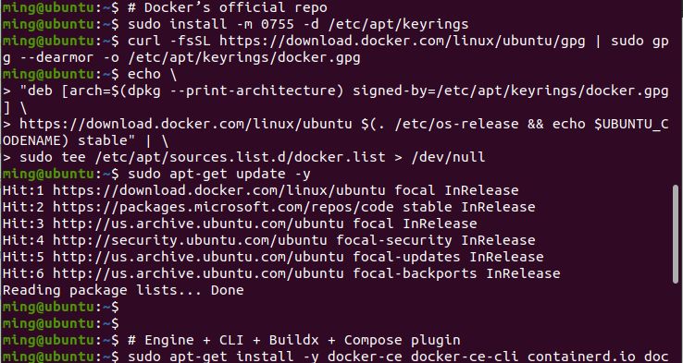

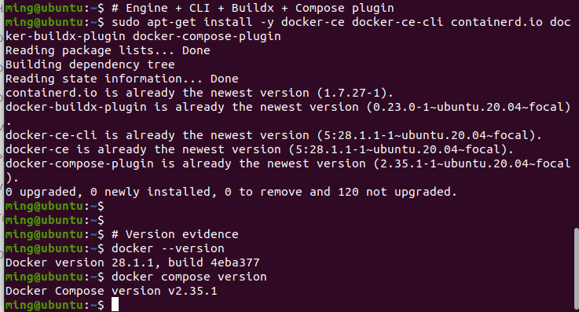

## 1.2 Restrict Docker to sudo only

Refresh session (so the group removal takes effect):

exec su -l "$USER" – Starts a fresh login shell so the group removal takes effect immediately.

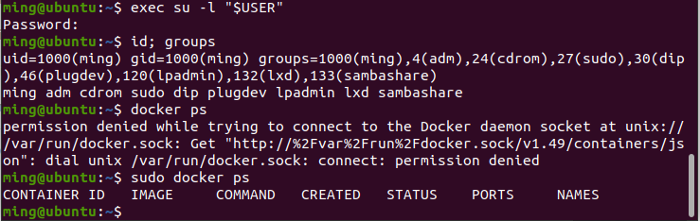

## 1.3 Short Security Summary (why this restriction matters)

* dockerd runs as root; access to /var/run/docker.sock is effectively root‑equivalent (you can start privileged containers, mount /, modify network/iptables, read host files, etc.).
* Requiring sudo enforces least privilege and records actions in sudo audit logs.
* This reduces the blast radius from compromised low‑priv accounts or scripts and prevents silent misuse of the Docker daemon.

# Task 2: Deploy Portainer for Docker Management

## 2.1 Download and inspect compose.yaml file.

Download the file from the blackboard and insert it into secdevops-a3/portainer folder.

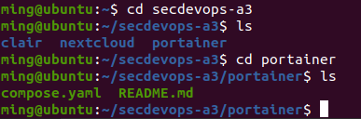

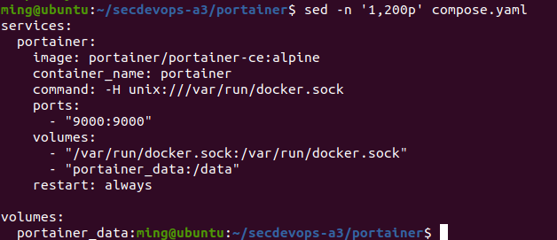

## 2.2 Valid restart options

* no – never restart (default if not set)
* on-failure[:N] – restart only on non‑zero exit (optionally up to N times)
* always – always restart if it stops
* unless-stopped – restart unless you explicitly stop it

## 2.3 Deploy Portainer stack

a. Report the steps with evidence (e.g., screenshots). You must show evidence that atleast one container is running. Additionally, report the detail of the deployed Portainer container (e.g., Status, Id etc).

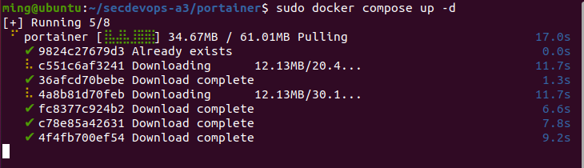

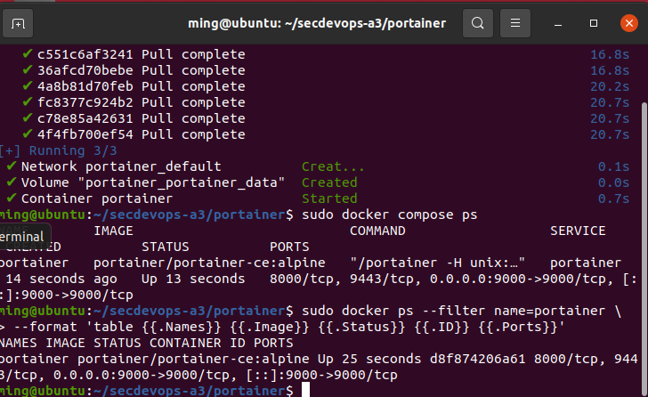

Evidence: screenshot docker compose ps showing at least one running container; screenshot the docker ps table (Status, ID, Ports).

b. Navigate in your web browser to access the Portainer web interface and create an account. Don’t forget to attach the related screenshot in the report.

http://192.168.147.136:9000

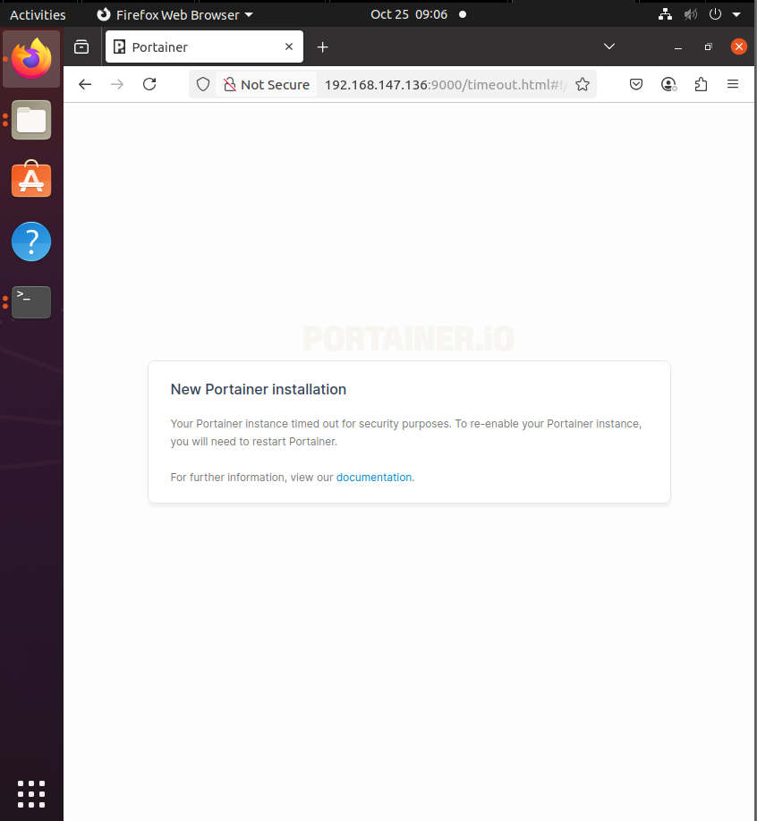

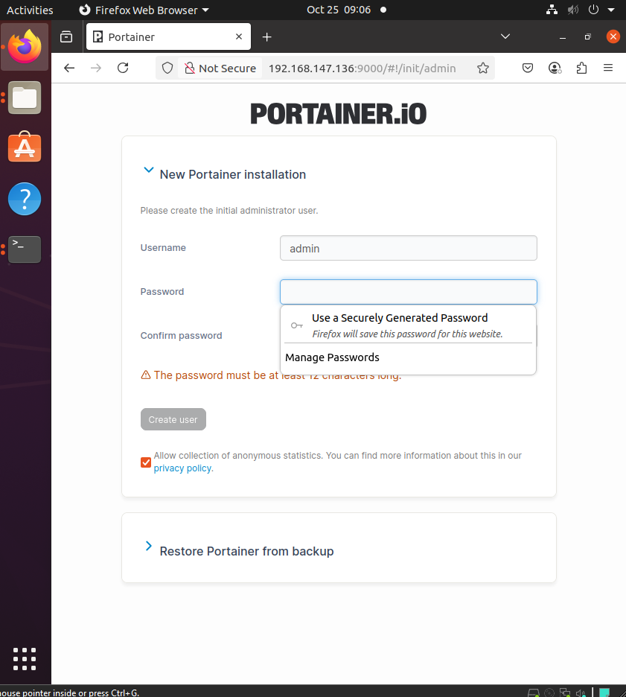

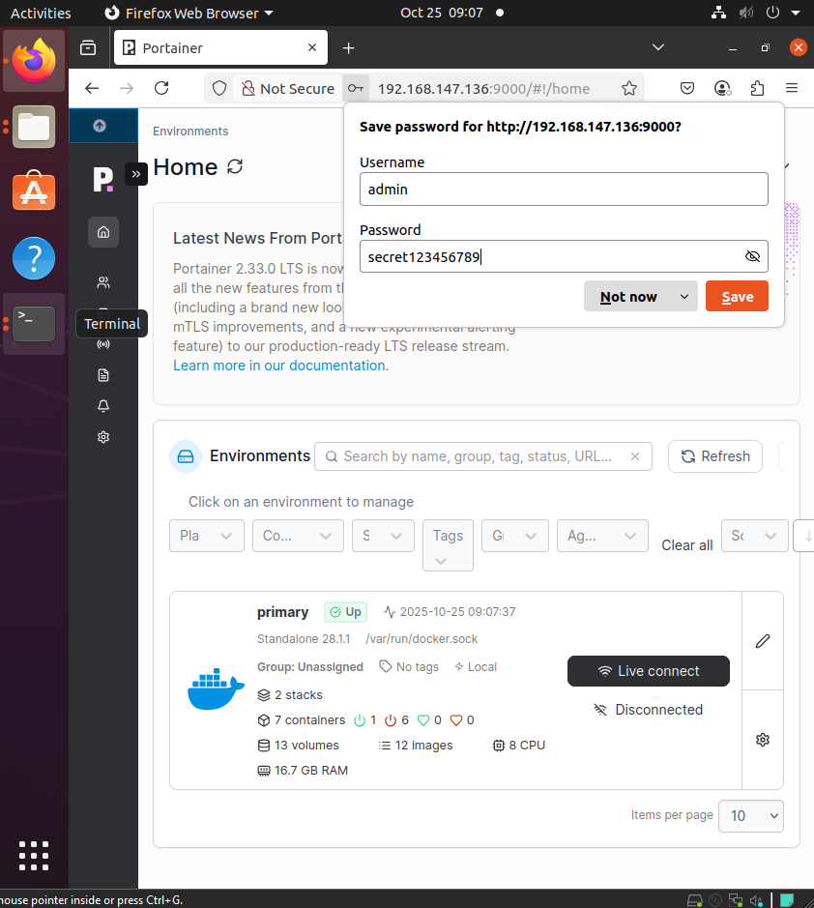

## 2.4 Access log monitoring

a. Show the three most recent lines of logs from the running stack. (Both the Docker-compose CLI command and output should be reported.)

sudo docker compose logs --tail=3

shows the most recent events from the running stack

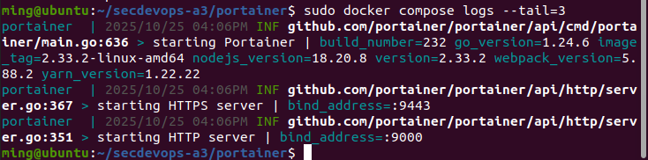

b. Access and filter Portainer log for any suspicious activities.

sudo docker logs portainer --since 30m 2>&1 | \

egrep -i 'fail|error|unauth|forbidden|denied|login|401|403|x509|tls' || true

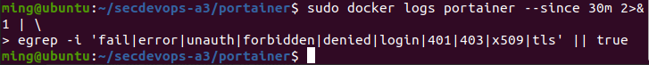

* “bind_address=:PORT” = the container is listening.
* Whether you can reach it from your host/browser depends on published ports (see sudo docker compose ps or sudo docker ps).
* In your case, you published 9000 → browse to <http://192.168.147.136:9000>. If you also publish 9443 in compose.yaml, you can use <https://192.168.147.136:9443> (preferred).

# Task 3: Setup a NextCloud stack with PostgreSQL

## 3.1 Inspect compose.yaml and explain expose:

cd ~/secdevops-a3/nextcloud

sed -n '1,200p' compose.yaml

awk '/^[[:space:]]*expose:/, /^[[:space:]]*[^- ]/ {print}' compose.yaml

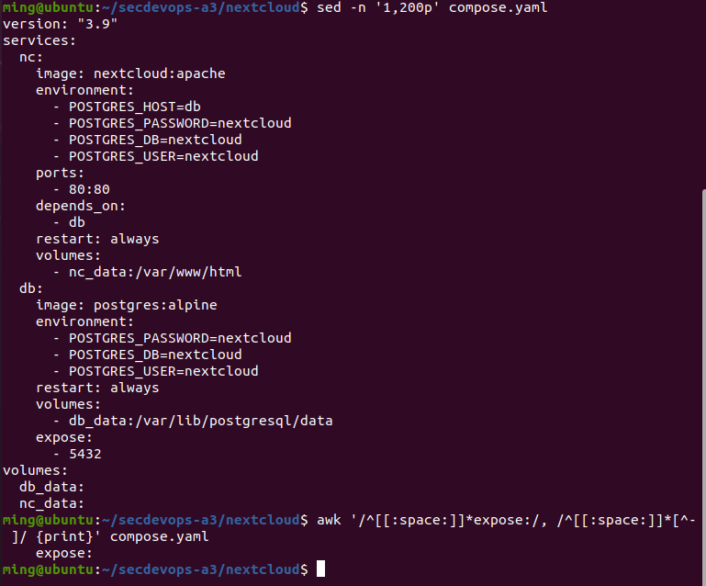

## 3.2 Deploy the Nextcloud + PostgreSQL stack

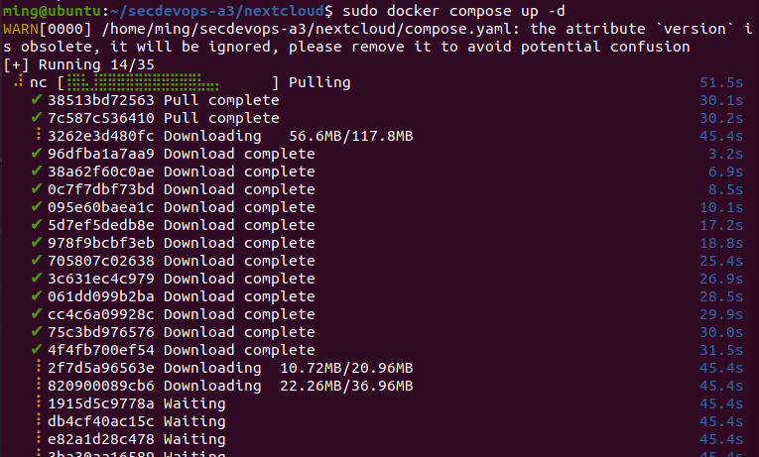

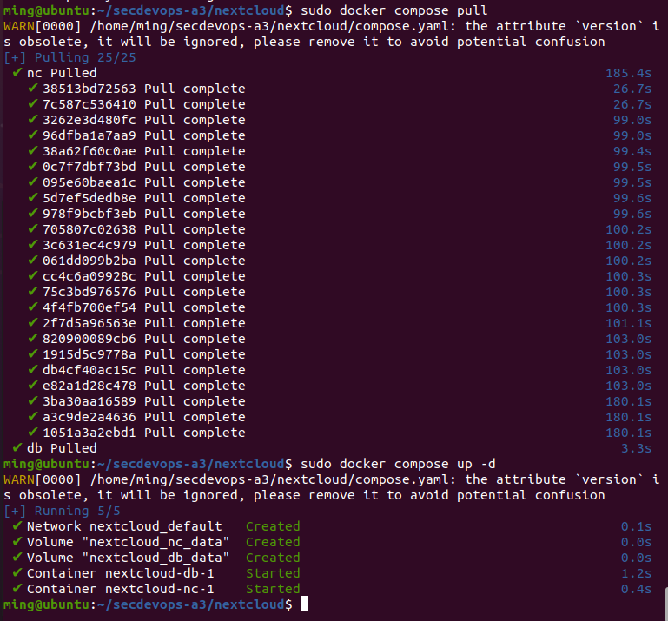

a. (i) Show the NextCloud web interface using your web browser, (ii) Report the fetched URL. Attach the related screen in the report.

http://192.168.147.136:80/

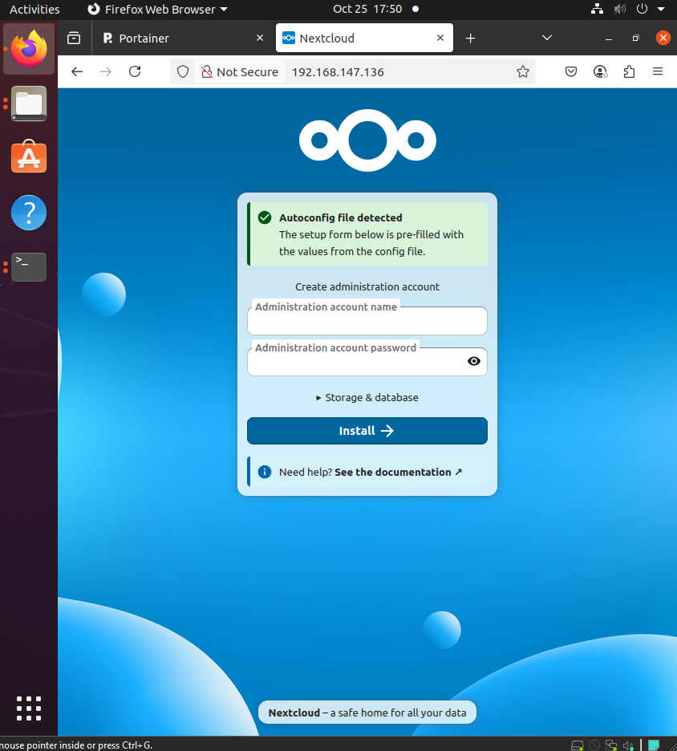

b. (i) Show the Portainer web interface using web browser after login to the portainer (refer Task 2). Attach the related screen in the report. (ii) Report the fetched URL. Attach the related screen in the report.

http://192.168.147.136:9000/#!/home

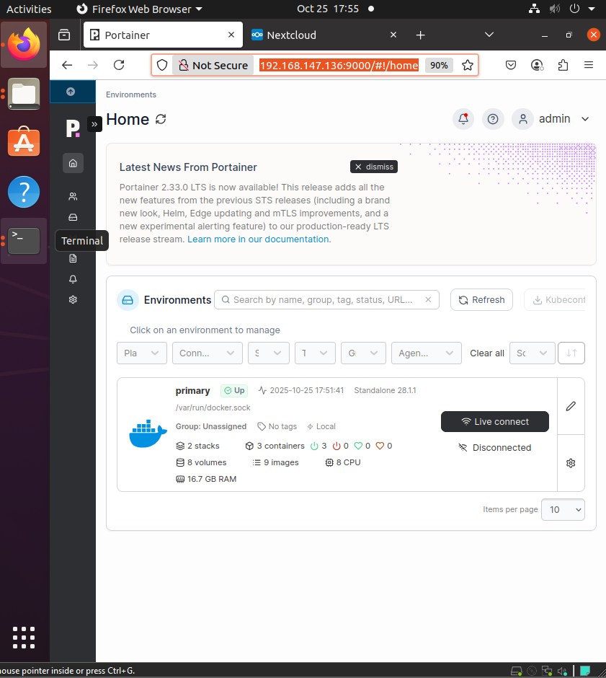

## 3.3 CLI management

1. sudo docker compose stop

sudo docker compose start

sudo docker compose restart

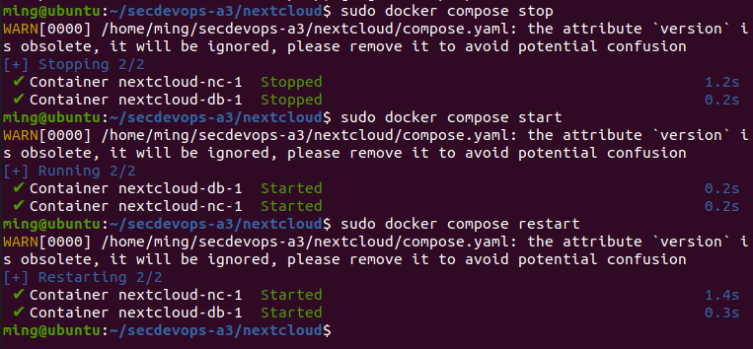

1. sudo docker compose ps

sudo docker ps --format 'table {{.Names}} {{.Image}} {{.Status}} {{.Ports}}'

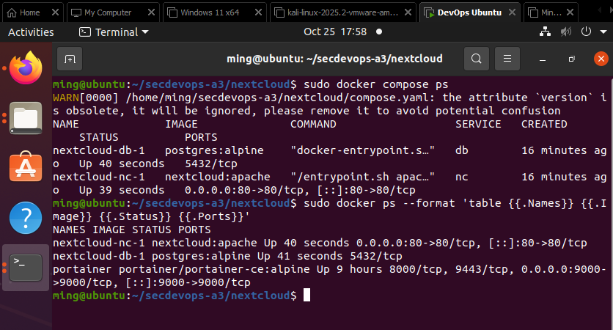

1. sudo docker compose logs -f --tail=80

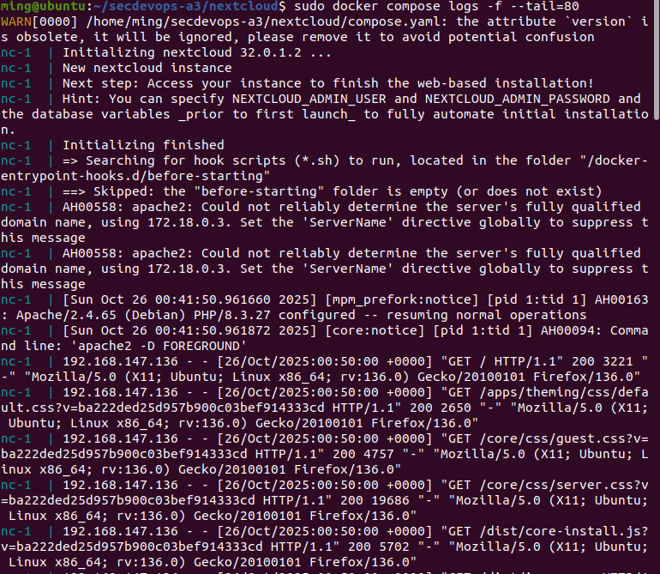

sudo docker compose logs -f nc --tail=80

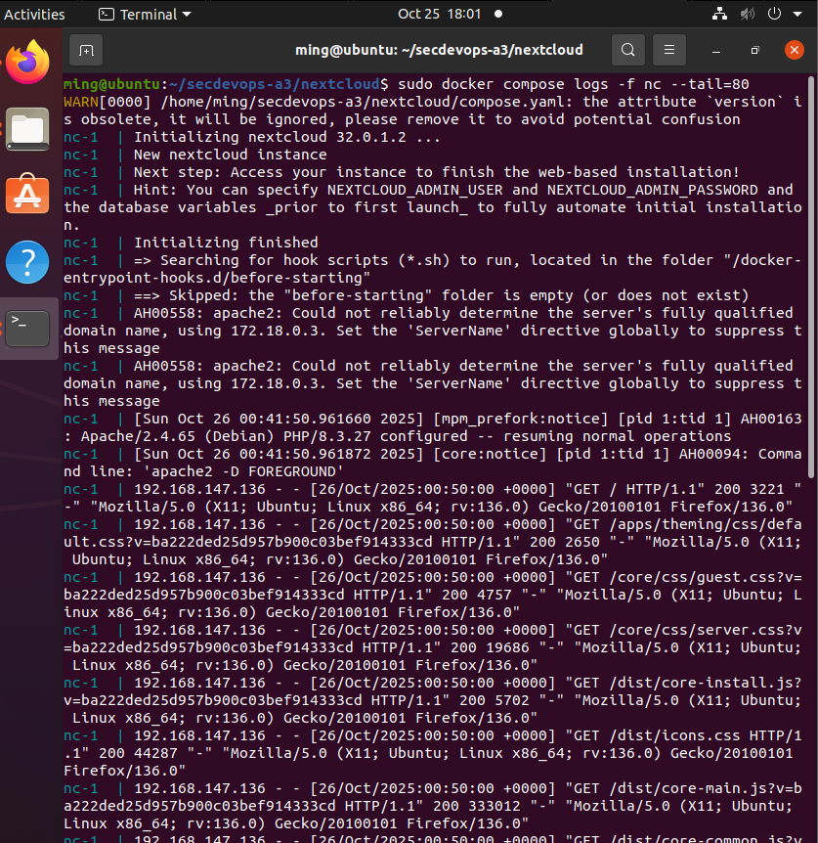

sudo docker compose logs -f db --tail=80

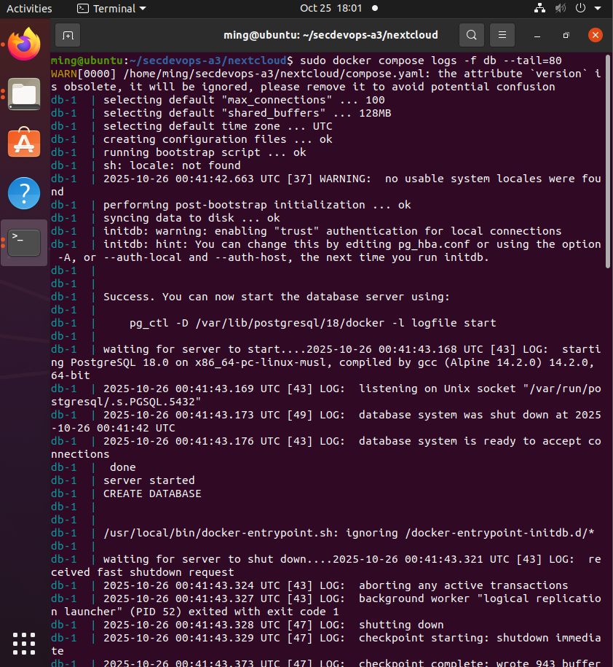

1. sudo docker compose logs --since 5m | sed -n '1,120p'

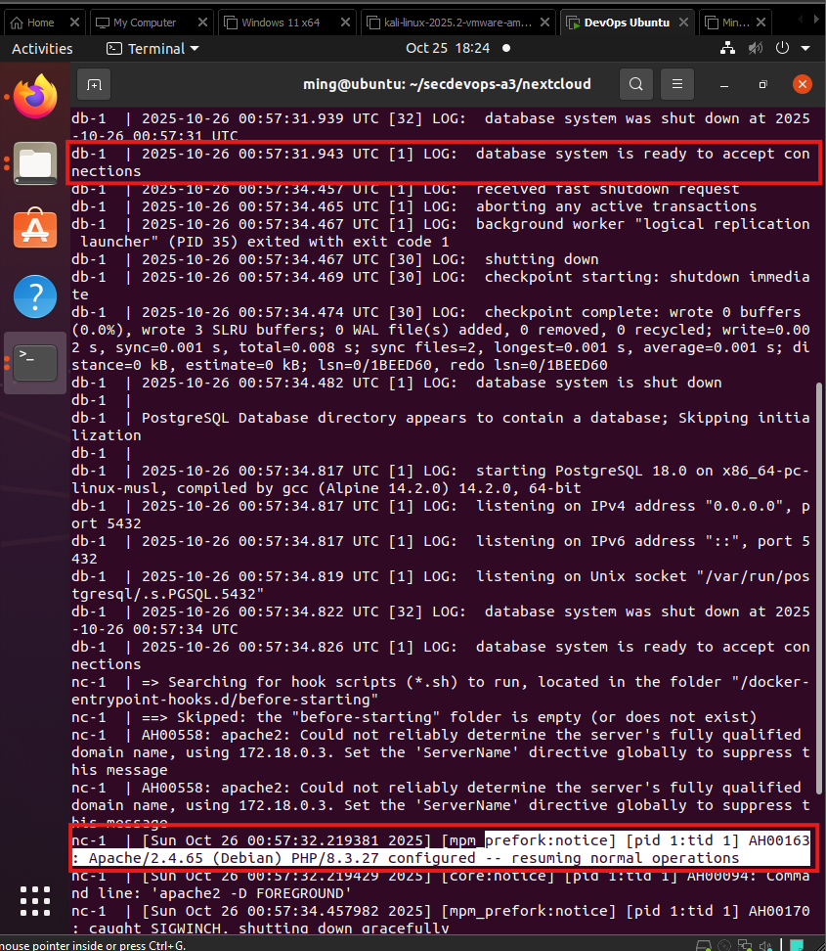

DB became ready first; Nextcloud/Apache started after.

e) sudo docker ps -f "label=com.docker.compose.project=nextcloud" \

--format 'table {{.Names}}\t{{.Image}}\t{{.ID}}\t{{.Status}}\t{{.Ports}}'

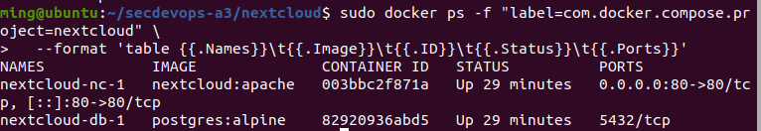

## 3.4 Ensure DB starts before Nextcloud

Edit file: ~/secdevops-a3/nextcloud/compose.yaml

Make db report healthy before nc starts.

Removes the obsolete version: key, adds DB healthcheck, and switches depends_on to condition: service_healthy.

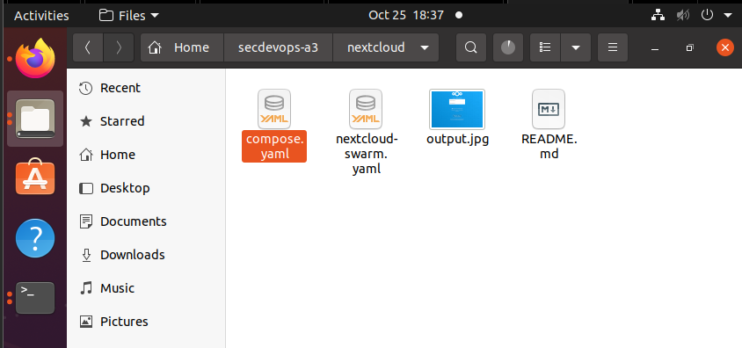

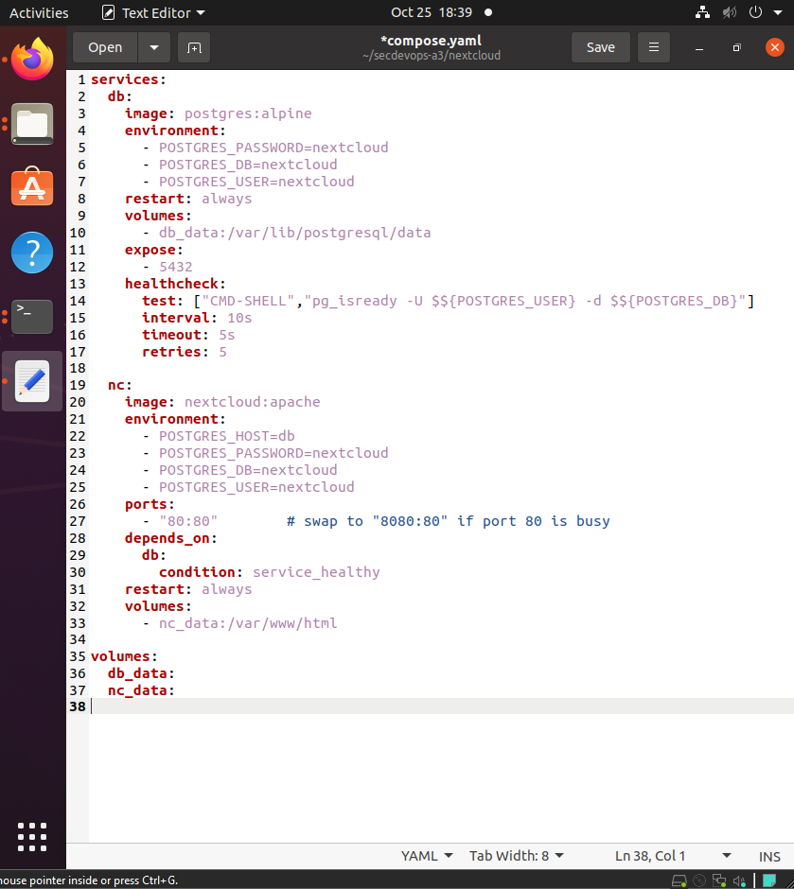

sudo docker compose config # quick syntax check

sudo docker compose up -d

sudo docker compose ps

sudo docker compose logs --since 2m | egrep -i 'ready|health|starting|postgres|apache' || true

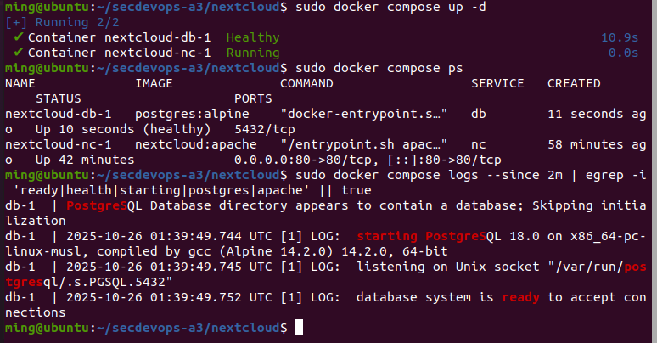

# Task 4: Container Security Scanning with Clair

## 4.1 Install PostgreSQL + Clair via Docker Compose

a. Get Clair source at a real release and build a local image

git clone --depth=1 --branch v4.8.0 https://github.com/quay/clair clair-src

cd clair-src

sudo docker build -t local/clair:v4.8.0 .

cd ..

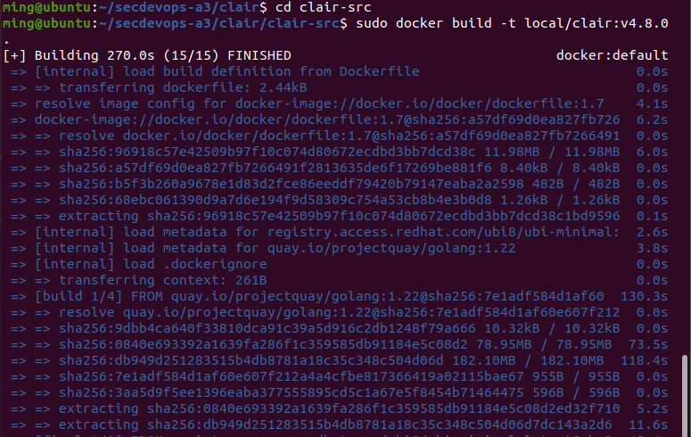

b&c) Compose file (uses local image + Postgres 13)

version: "3.9"

services: postgres: image: postgres:13 restart: unless-stopped environment: POSTGRES_USER: clair POSTGRES_PASSWORD: Cl@irP4ss!2025 POSTGRES_DB: clair6000 volumes: - clair_db:/var/lib/postgresql/data # persistent DB storage healthcheck: test: ["CMD-SHELL","pg_isready -U $${POSTGRES_USER} -d $${POSTGRES_DB}"] interval: 10s timeout: 5s retries: 5

clair: # if you built locally already, keep this: image: local/clair:v4.8.0 # otherwise try the registry tag (only if it exists for you): # image: quay.io/projectquay/clair:4.8.0 restart: unless-stopped # container restarts on crash depends_on: postgres: condition: service_healthy # wait for DB to be ready ports: - "6063:6060" # host:container — Clair API (404 at / is expected) - "8089:8089" # introspection (/health, /metrics) environment: - CLAIR_DATABASE=postgres://clair:Cl@irP4ss!2025@postgres:5432/clair6000?sslmode=disable - CLAIR_UPDATER_ENABLED=true - CLAIR_NOTIFIERS_ENABLED=false # set true only if you wire a notifier service - CLAIR_NOTIFIERS_ENDPOINT=<http://clair-notifier:6061/notify> - CLAIR_API_MAXCONN=1024 # Clair v4 requires a config file. We mount a minimal working one and point Clair to it: volumes: - ./config.yaml:/etc/clair/config.yaml:ro command: ["-conf","/etc/clair/config.yaml","-mode","combo"]

volumes: clair_db:

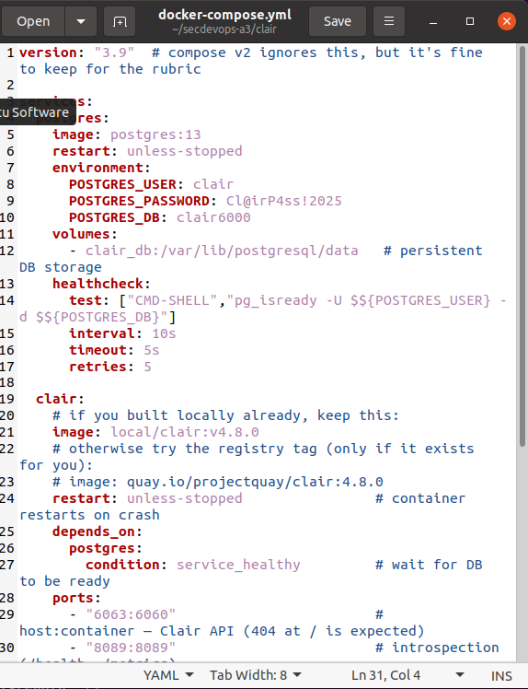

Minimal Clair config (single DB named clair6000)

cat > config.yaml <<EOF

http_listen_addr: :6060

log_level: info

indexer:

connstring: host=clair-db port=5432 user=clair password=${CLAIR_DB_PASS} dbname=clair6000 sslmode=disable

migrations: true

matcher:

connstring: host=clair-db port=5432 user=clair password=${CLAIR_DB_PASS} dbname=clair6000 sslmode=disable

migrations: true

indexer_addr: <http://clair:6060>

notifier:

connstring: host=clair-db port=5432 user=clair password=${CLAIR_DB_PASS} dbname=clair6000 sslmode=disable

migrations: true

EOF

# start services

sudo docker compose up -d

sudo docker compose ps

# verify DB exists (psql defaults to -d <user>; explicitly connect to postgres or clair6000)

sudo docker compose exec -T clair-db psql -U clair -d postgres -c '\l' # shows clair6000

sudo docker compose exec -T clair-db psql -U clair -d clair6000 -c 'SELECT 1;'

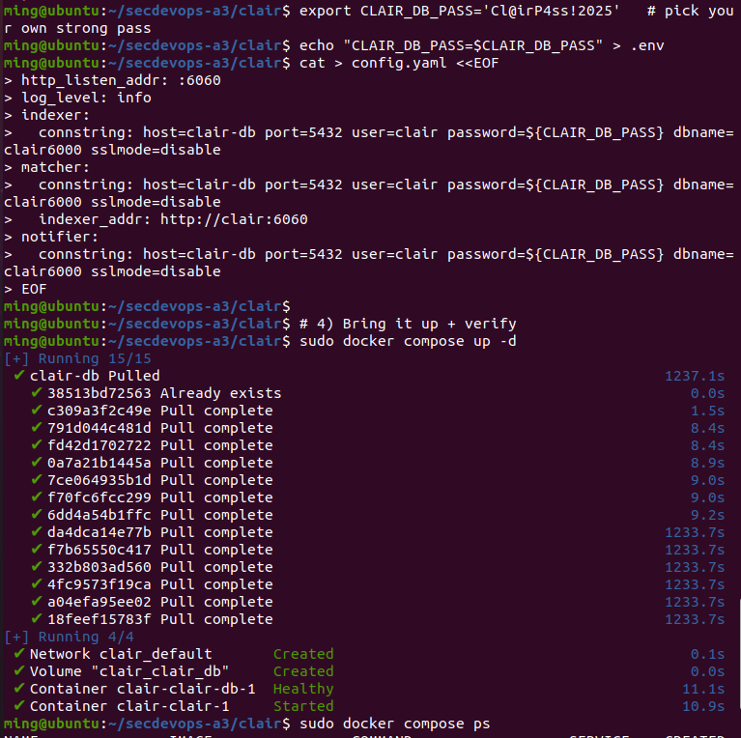

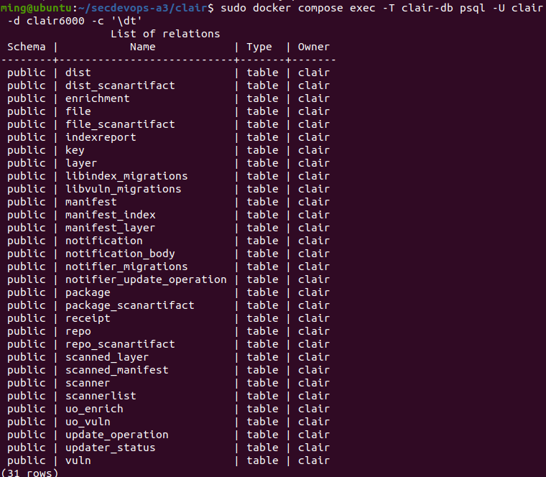

d. Start Clair service

sudo docker compose ps

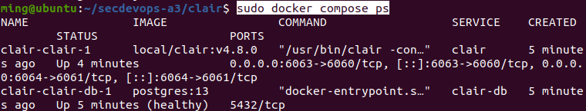

sudo docker compose logs --tail=120 clair | egrep -i 'ready|initialize|serv|migrat'

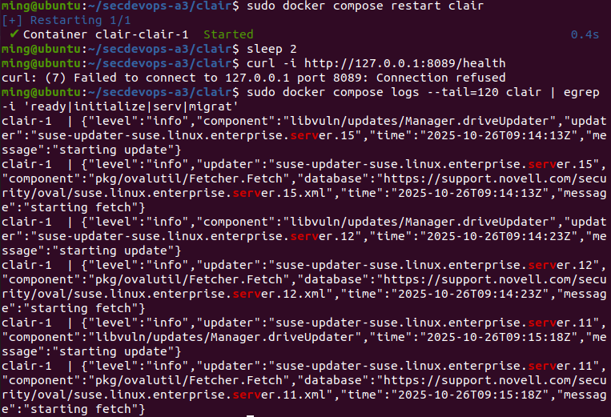

sudo docker compose ps

sudo docker compose exec -T clair-db psql -U clair -d clair6000 -c '\dt' # shows migrated tables

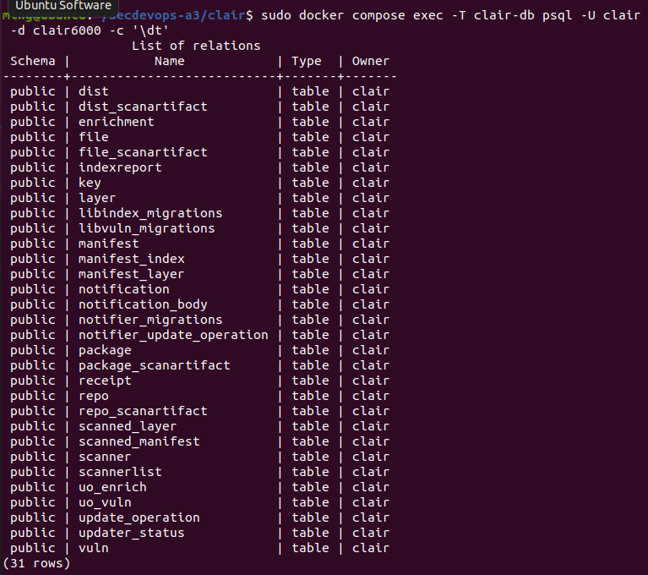

1. To show that API is reachable

curl -i http://127.0.0.1:6063/

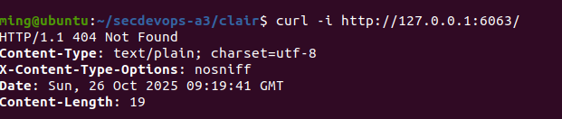

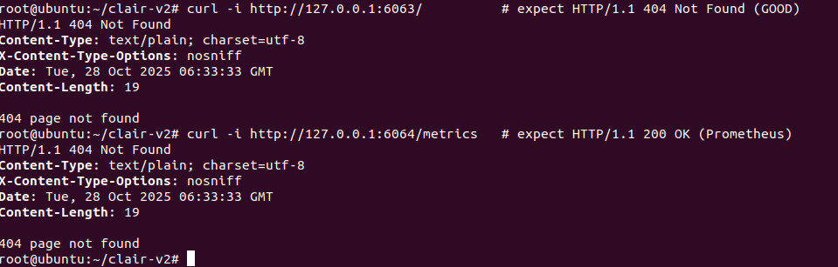

## 4.2 Perform Container Security Scanning

a. Installing clairctl

# clone and install Clairctl

cd ~

git clone <https://github.com/jgsqware/clairctl.git>

cd clairctl

go build # or download from the GitHub release binary

# verify installation

clairctl version

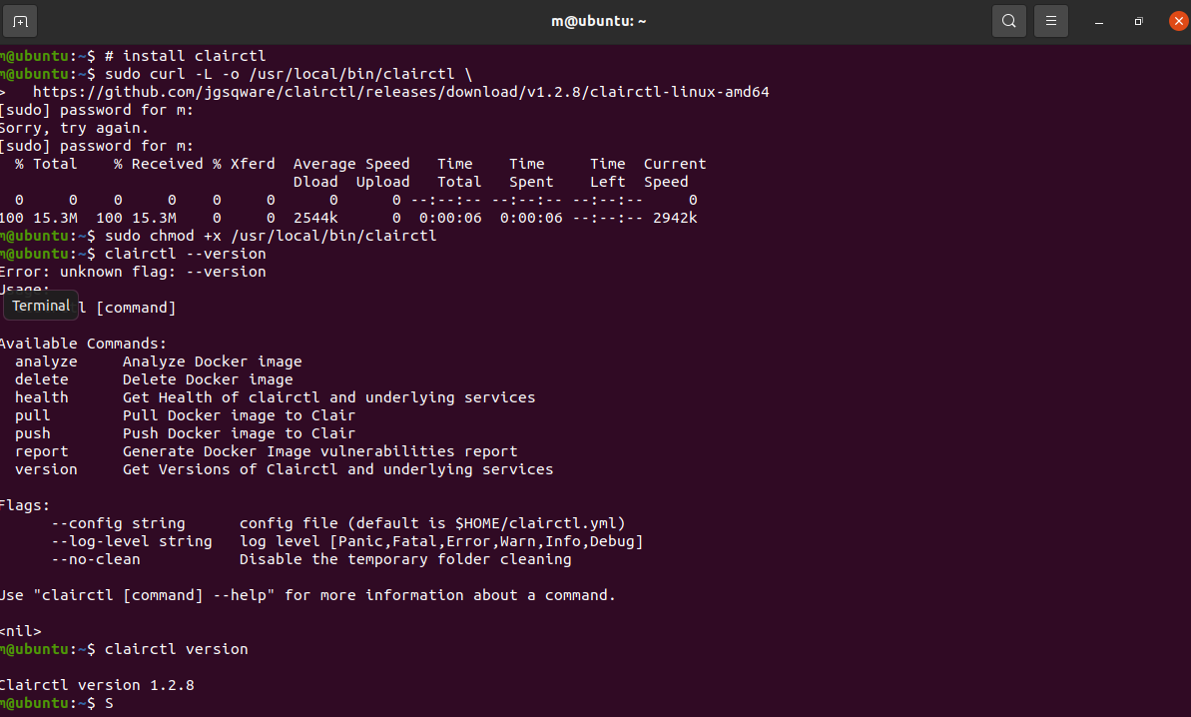

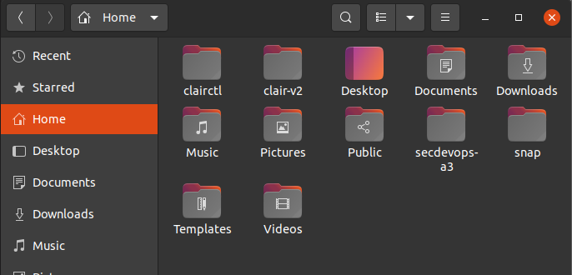

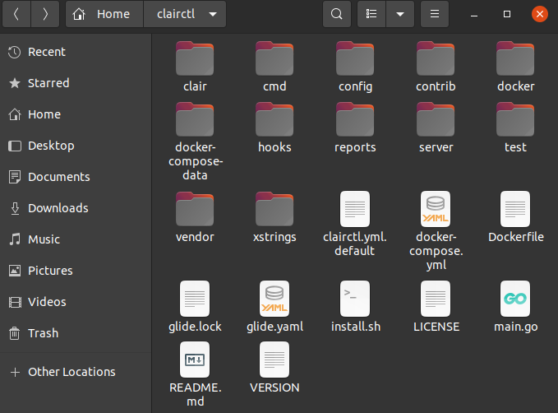

cat > ~/.clairctl.yml <<'YAML'

clair:

uri: http://clair

port: 6060

healthPort: 6061

report:

path: /root/clairctl/reports

docker:

insecure-ssl: true

registry:

- name: registry

uri: https://registry:5000

insecure-ssl: true

YAML

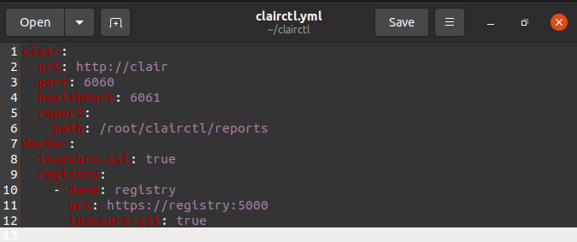

version: '2.1'

services: postgres: image: postgres:9.6 restart: unless-stopped volumes: - ./docker-compose-data/postgres-data/:/var/lib/postgresql/data:rw environment: - POSTGRES_PASSWORD=ChangeMe - POSTGRES_USER=clair - POSTGRES_DB=clair

clair: image: quay.io/coreos/clair:v2.0.0 restart: unless-stopped volumes: - ./docker-compose-data/clair-config/:/config/:ro - ./docker-compose-data/clair-tmp/:/tmp/:rw depends_on: postgres: condition: service_started command: [--log-level=debug, --config, /config/config.yml]

clairctl: image: jgsqware/clairctl:latest restart: unless-stopped environment: - DOCKER_API_VERSION=1.24 volumes: - ./docker-compose-data/clairctl-reports/:/reports/:rw - /var/run/docker.sock:/var/run/docker.sock:ro depends_on: clair: condition: service_started

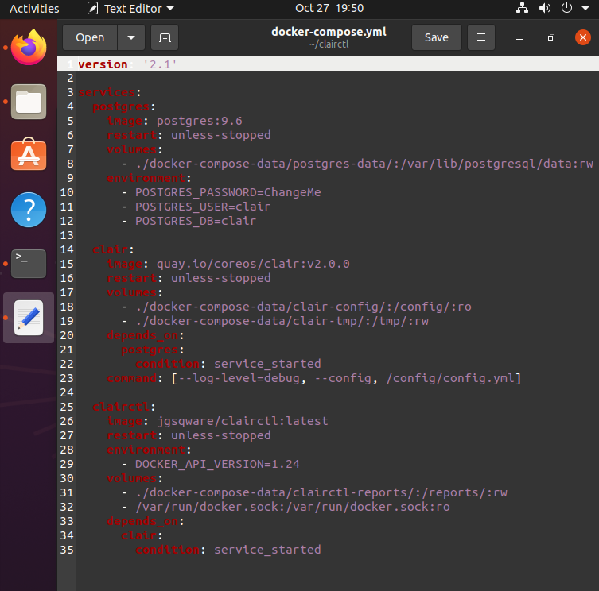

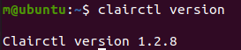

b. Scanning the NextCloud image

Push Nextcloud to local registry

docker run -d --restart=always --name registry -p 5000:5000 registry:2

docker tag nextcloud:latest localhost:5000/nextcloud:latest

docker push localhost:5000/nextcloud:latest

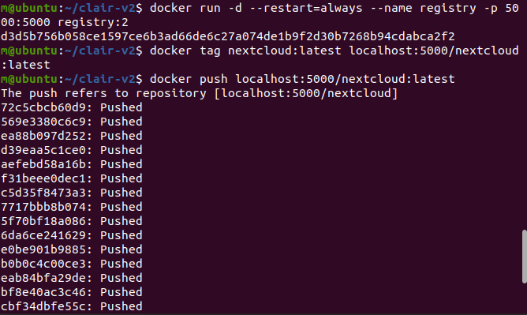

curl -i http://127.0.0.1:6063/ | head -n1

clairctl --config ~/.clairctl.yml health

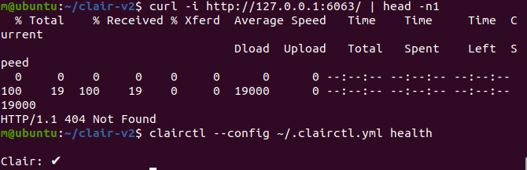

docker tag nextcloud:latest localhost:5000/nextcloud:latest

docker push localhost:5000/nextcloud:latest

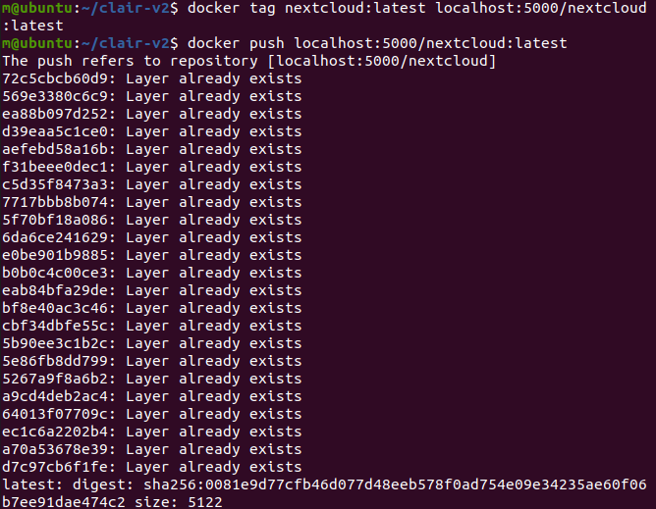

NET=clair-v2_clairnet

mkdir -p ~/clairctl/reports

# analyze

docker run --rm -it --network "$NET" -u 0:0 \

-e TZ=Australia/Perth -v /etc/localtime:/etc/localtime:ro \

-v /var/run/docker.sock:/var/run/docker.sock \

-v $HOME/.clairctl.yml:/root/.clairctl.yml:ro \

-v $HOME/clairctl:/root/clairctl \

jgsqware/clairctl:latest \

clairctl --config /root/.clairctl.yml --log-level Debug analyze registry:5000/nextcloud:latest

# HTML report

docker run --rm -it --network "$NET" -u 0:0 \

-e TZ=Australia/Perth -v /etc/localtime:/etc/localtime:ro \

-v /var/run/docker.sock:/var/run/docker.sock \

-v $HOME/.clairctl.yml:/root/.clairctl.yml:ro \

-v $HOME/clairctl:/root/clairctl \

jgsqware/clairctl:latest \

clairctl --config /root/.clairctl.yml report registry:5000/nextcloud:latest --format html

# JSON report saved to host

docker run --rm -it --network "$NET" -u 0:0 \

-e TZ=Australia/Perth -v /etc/localtime:/etc/localtime:ro \

-v /var/run/docker.sock:/var/run/docker.sock \

-v $HOME/.clairctl.yml:/root/.clairctl.yml:ro \

-v $HOME/clairctl:/root/clairctl \

jgsqware/clairctl:latest \

sh -lc 'clairctl --config /root/.clairctl.yml report registry:5000/nextcloud:latest --format json > /root/clairctl/reports/nextcloud.json'

# receipts for your appendix

ls -l --time-style='+%F %T %z' ~/clairctl/reports

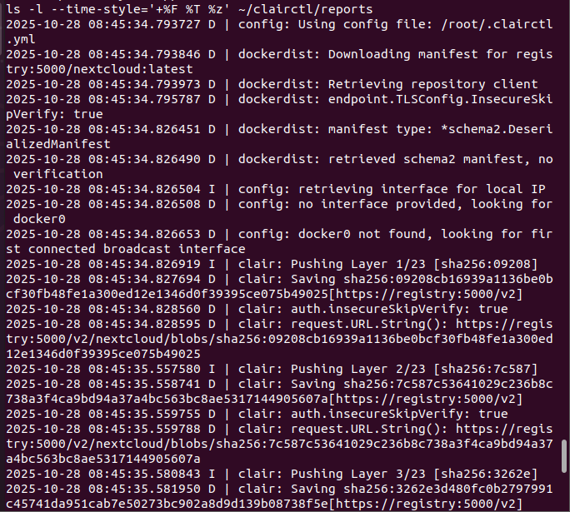

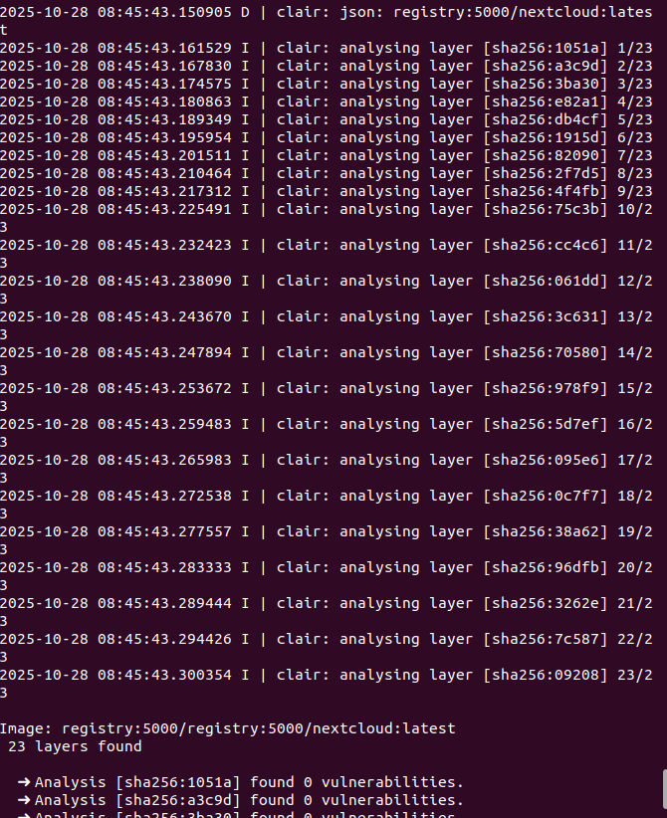

c. Generating and reviewing the report.

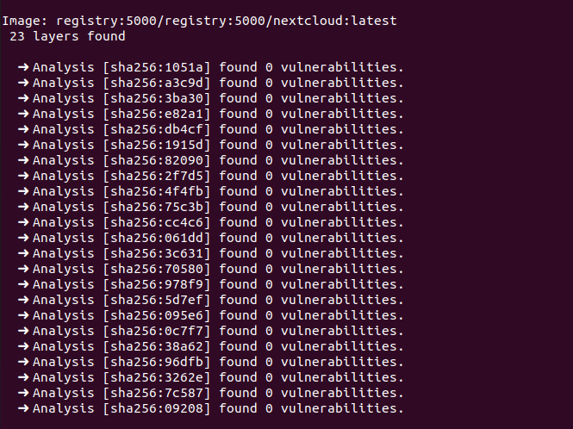

mkdir -p ~/clairctl/reports

clairctl --config ~/.clairctl.yml report ${BRIDGE_IP}:5000/nextcloud:latest --format html

ls -la ~/clairctl/reports

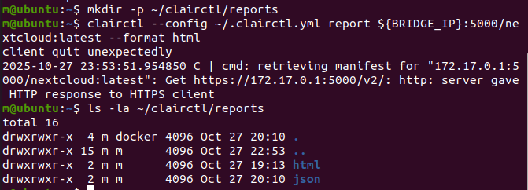

ls -lh reports/html

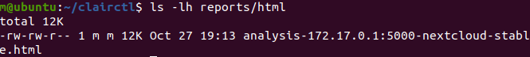

xdg-open reports/html/analysis-172.17.0.1:5000-nextcloud-stable.html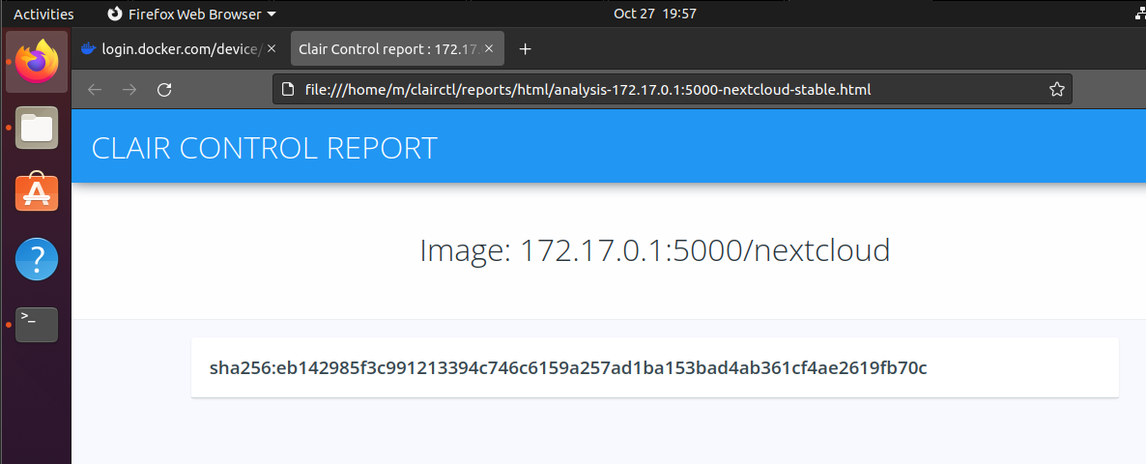

**D. Remediation notes**

- Base image hygiene: keep Nextcloud at latest (pull updated tag regularly).

- Patch cadence: rebuild/push when upstream OS packages patch CVEs.

- Hardening: run as non-root, add minimal capabilities, enforce read-only FS where possible, pin digest for immutability.

# Task 5: AWS CodePipeline for Node.js

Repository: <https://github.com/mingyongtan/express-es6-sample>

Actions:

* Forked from jcunanan05/express-es6-sample
* Kept private (OAuth used)
* Latest commit: aba33a21 (includes buildspec-build.yml, buildspec-test.yml)

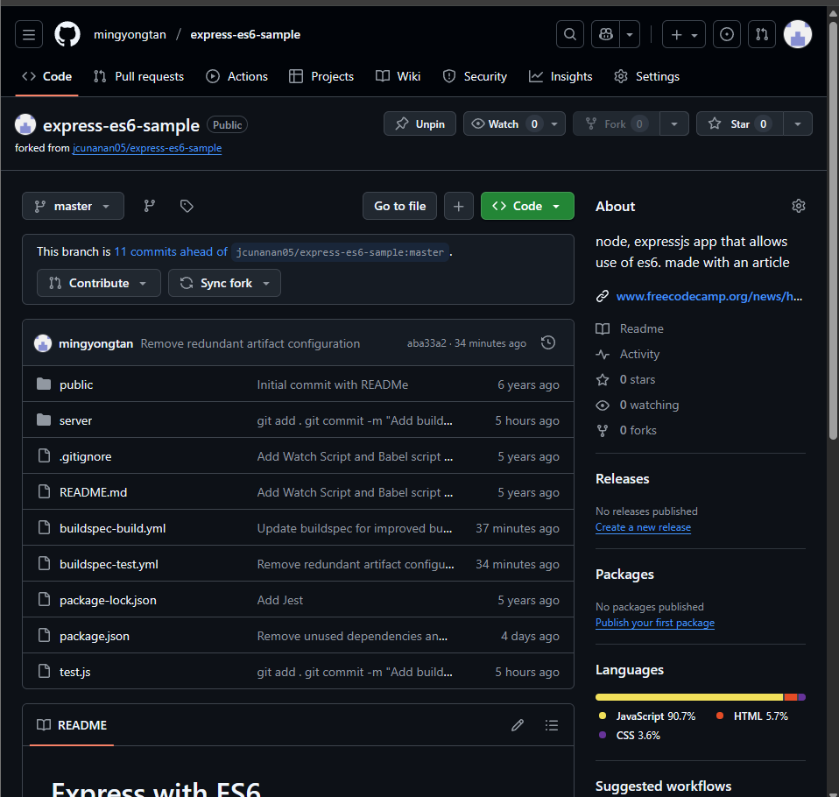  
Replace package.json

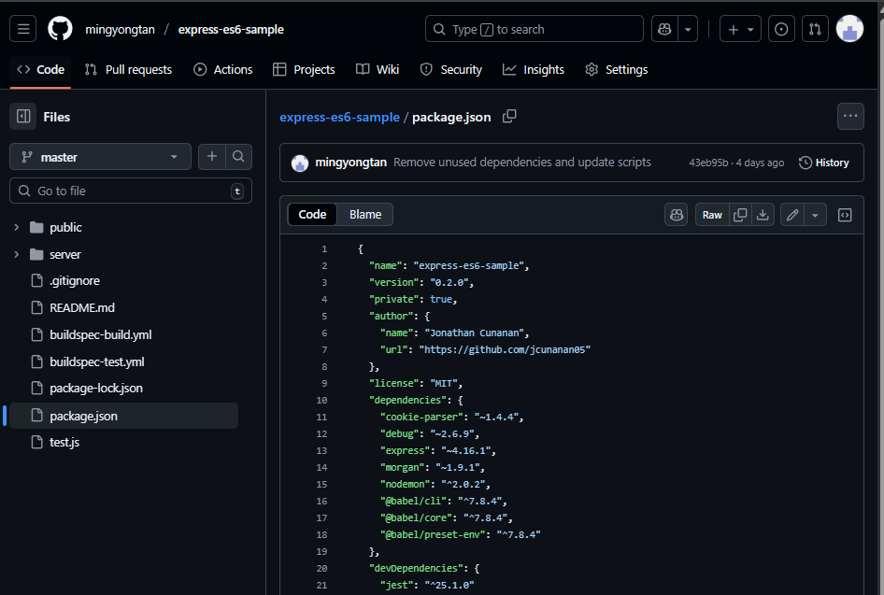

git clone https://github.com/mingyongtan/express-es6-sample.git

cd express-es6-sample

cp ~/Downloads/package.json ./package.json # replace with the provided one

git add package.json

git commit -m "Replace package.json per assignment spec"

git push origin master

Create AWS codepipeline

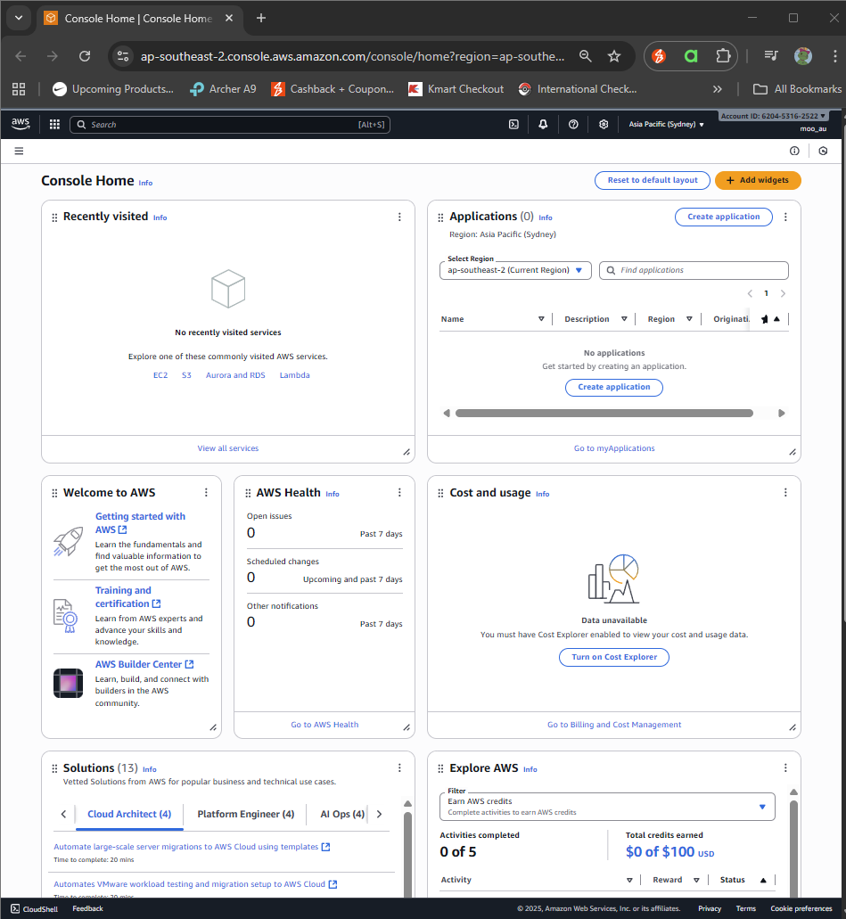

Configure AWS CodePipeline

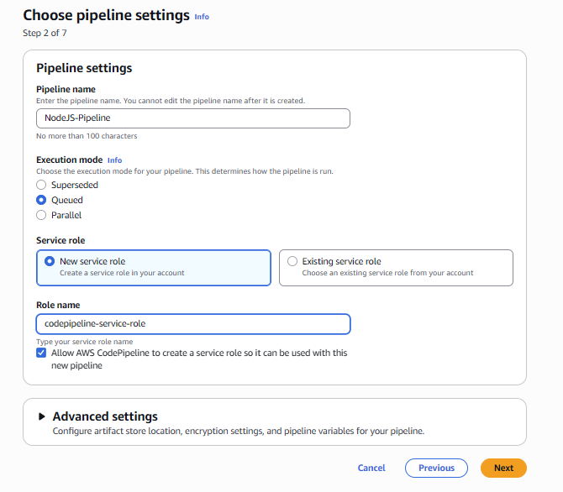

### Stage 1: Source

Oauth github with aws first.

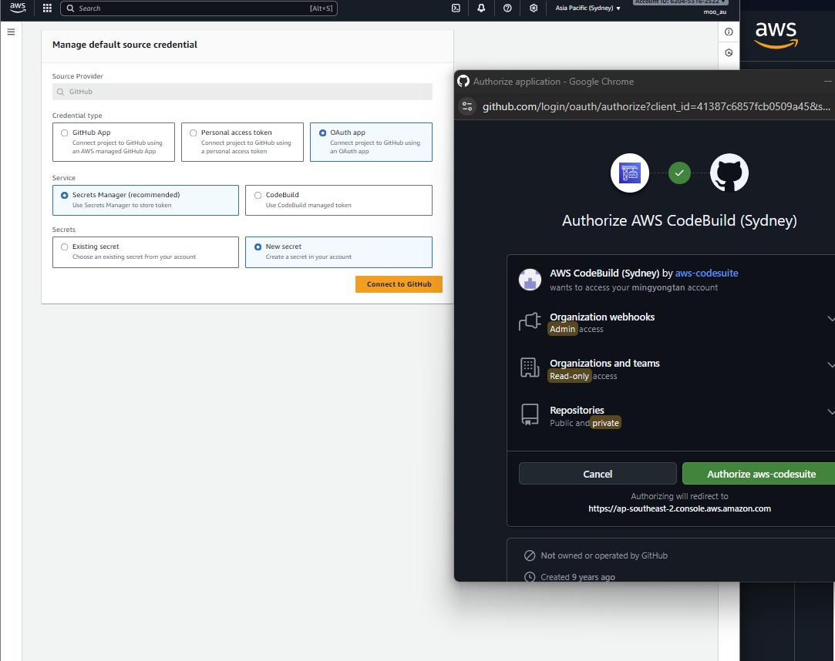

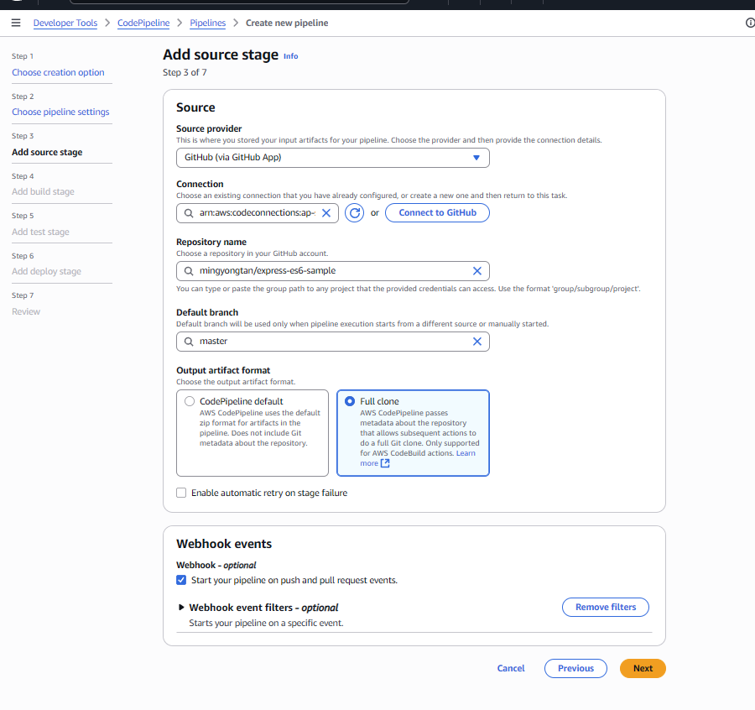

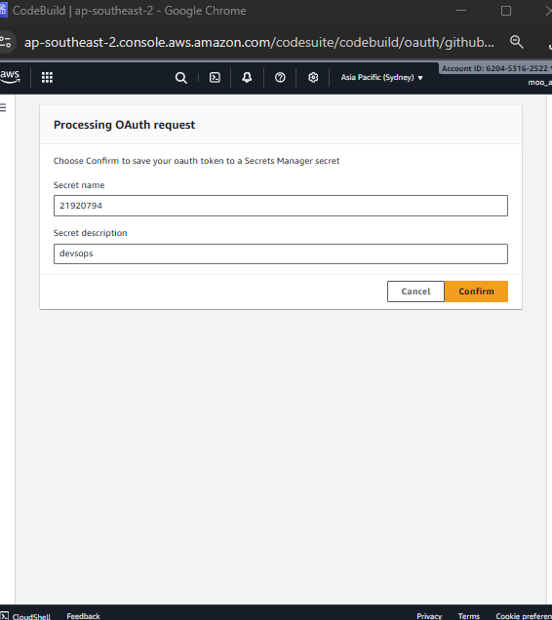

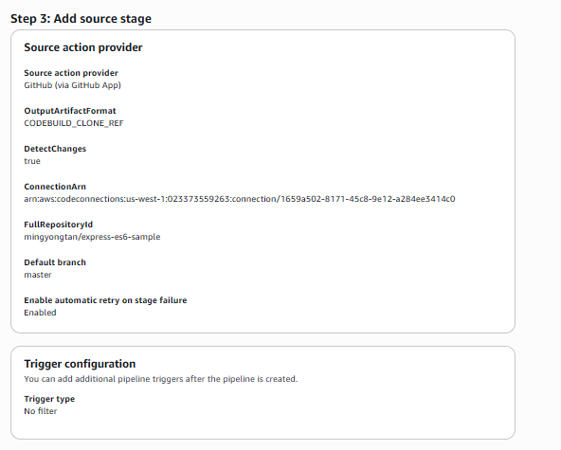

### Stage 2: Build

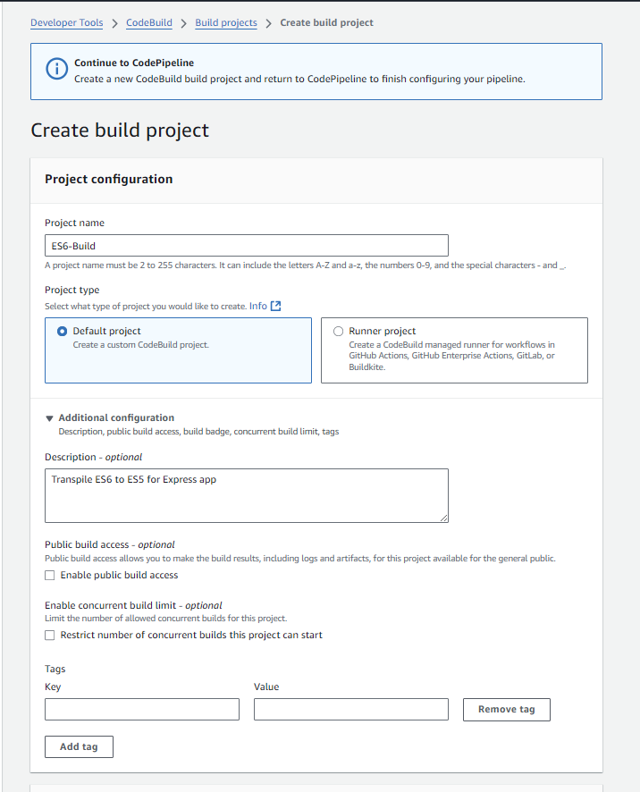

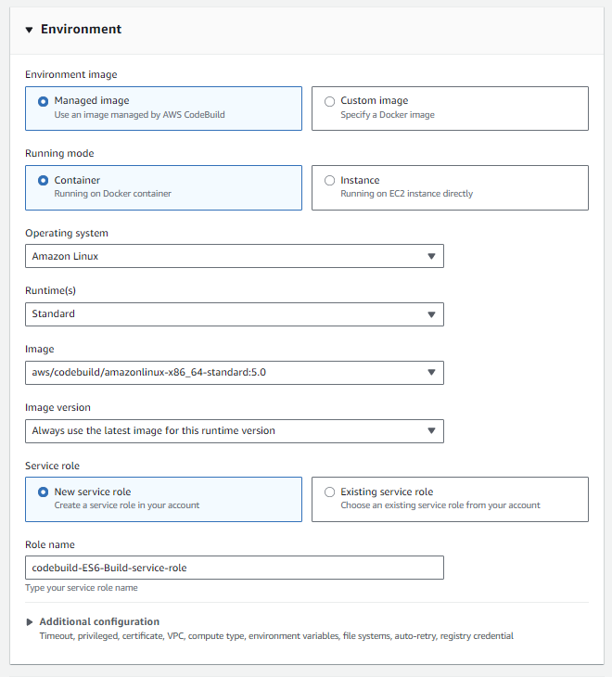

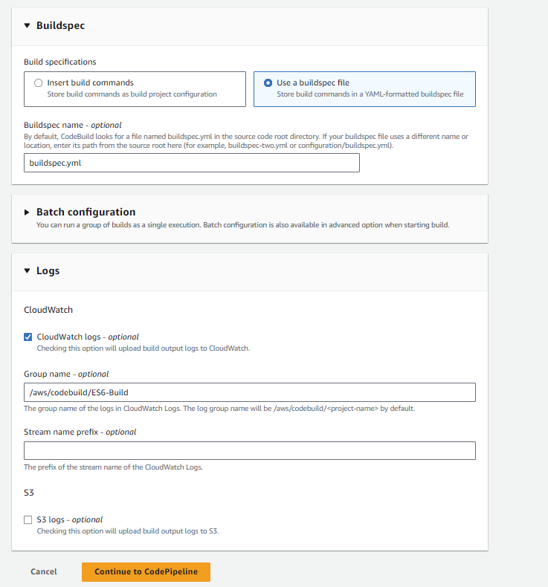

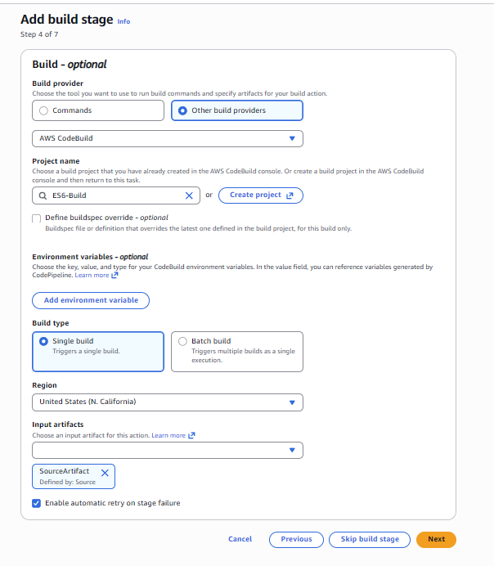

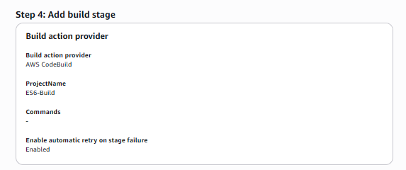

### Stage 3: Test

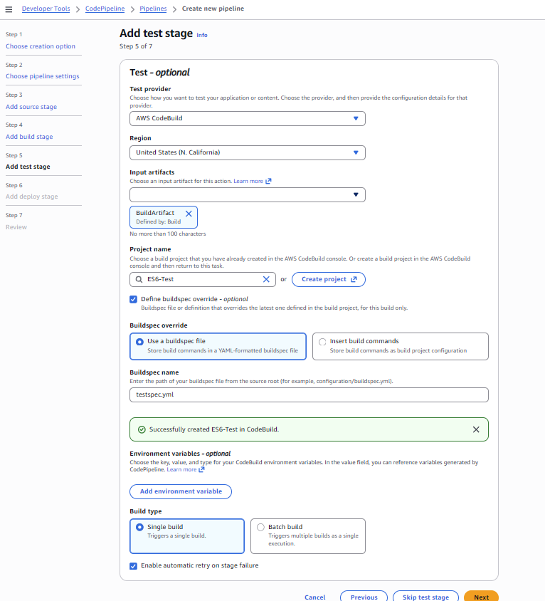

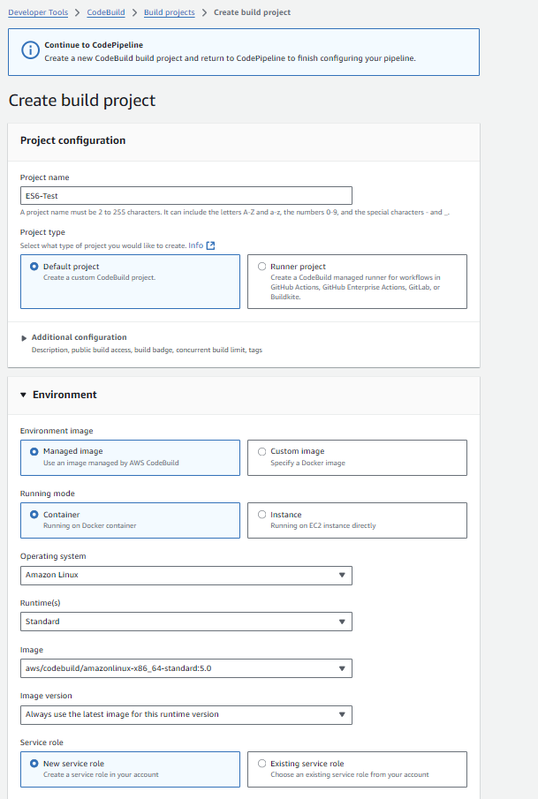

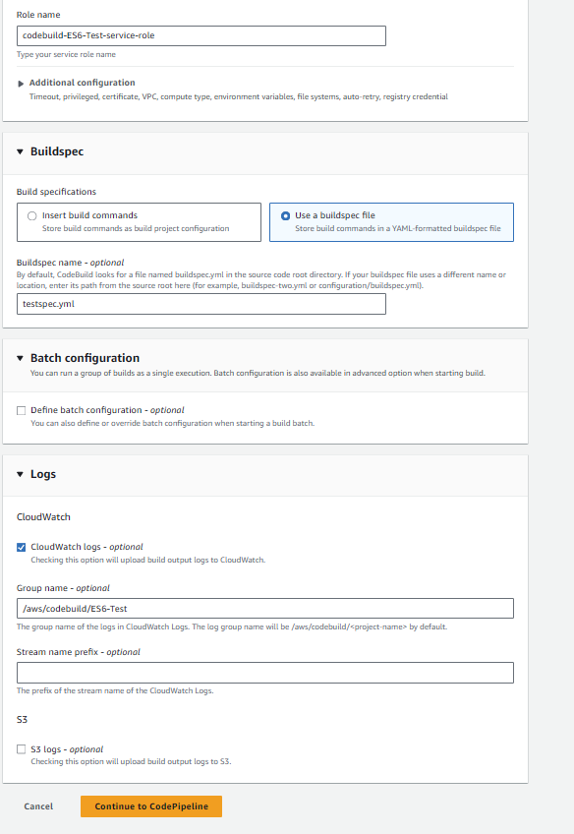

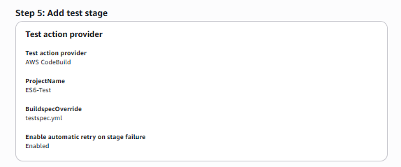

### Stage 4 Delopy

Need to precreate the environment and application first.

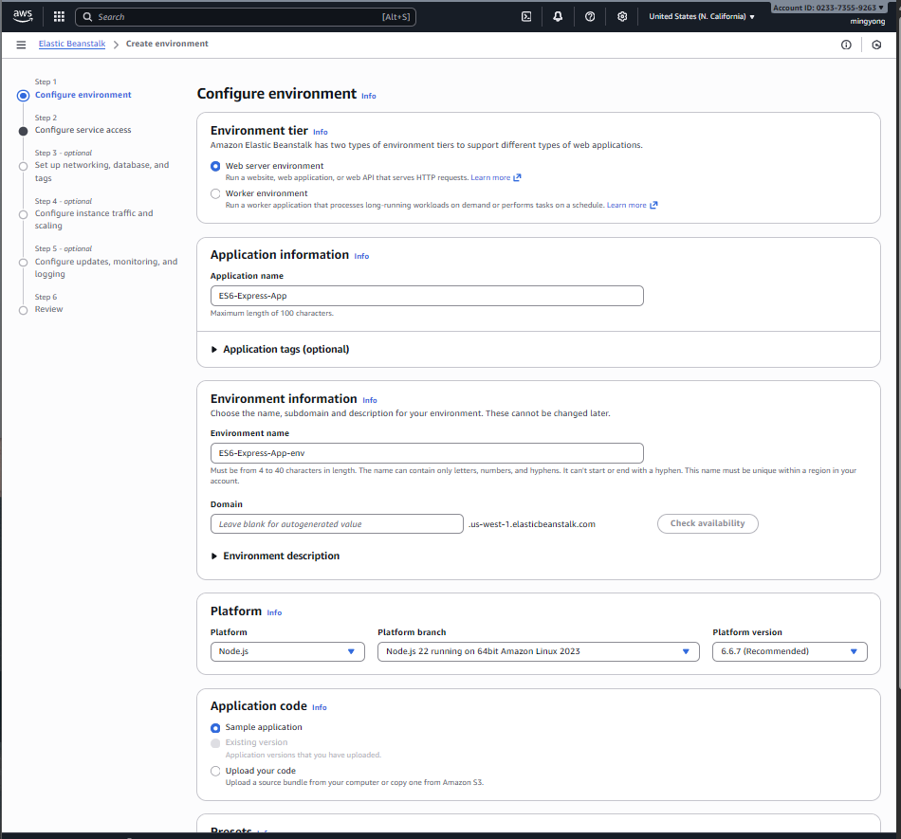

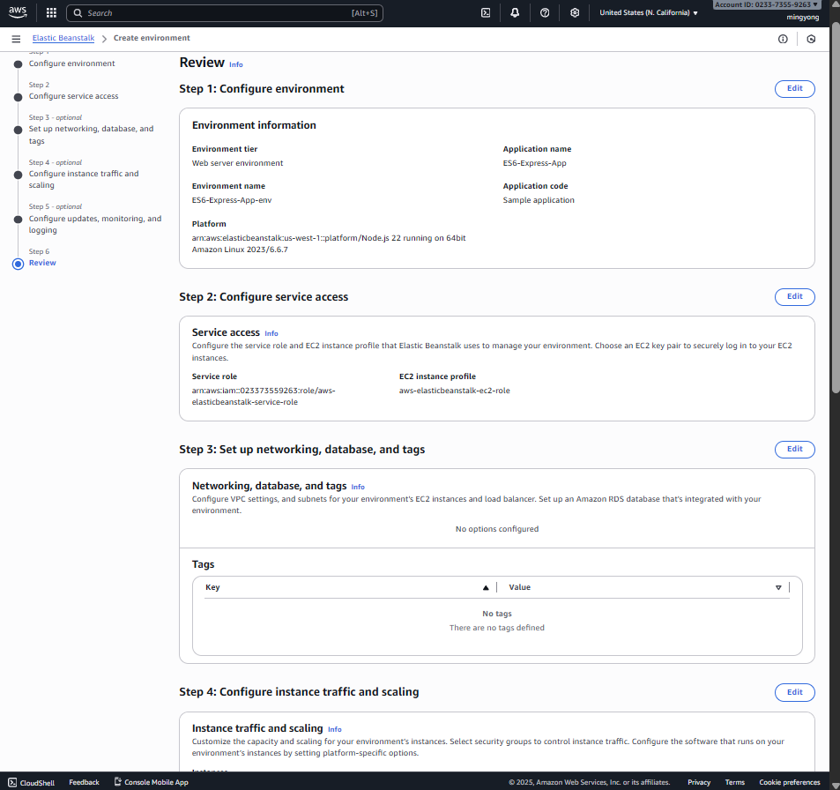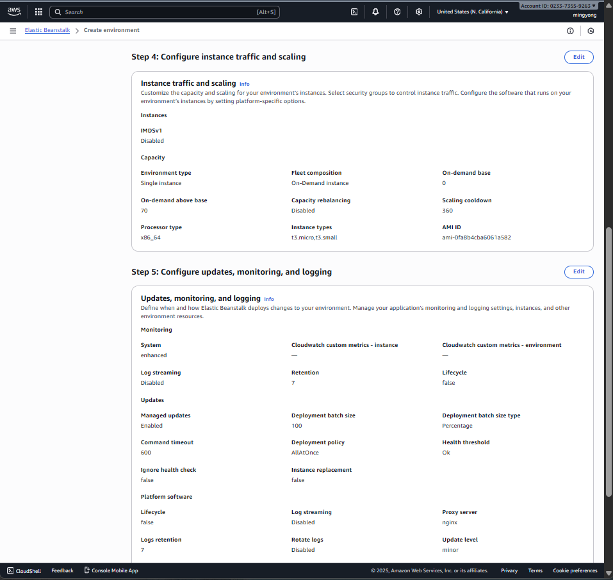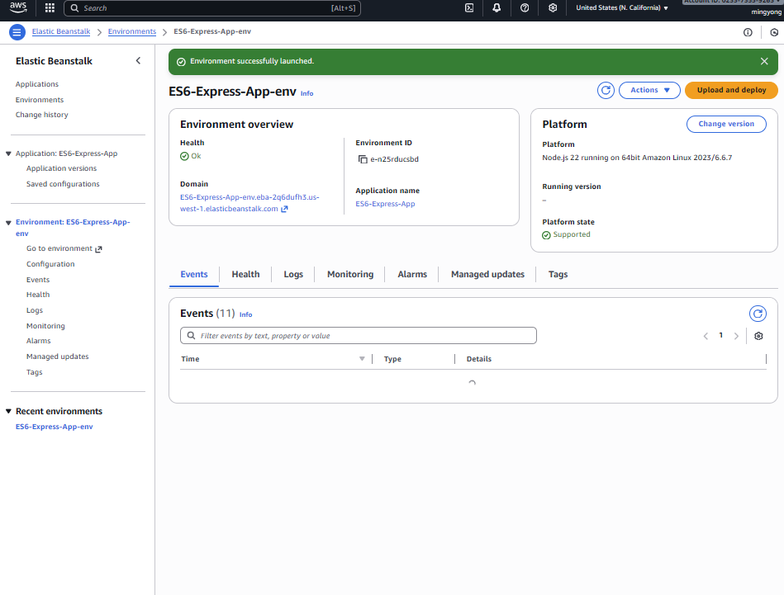

Create IAM role for application and envoironmet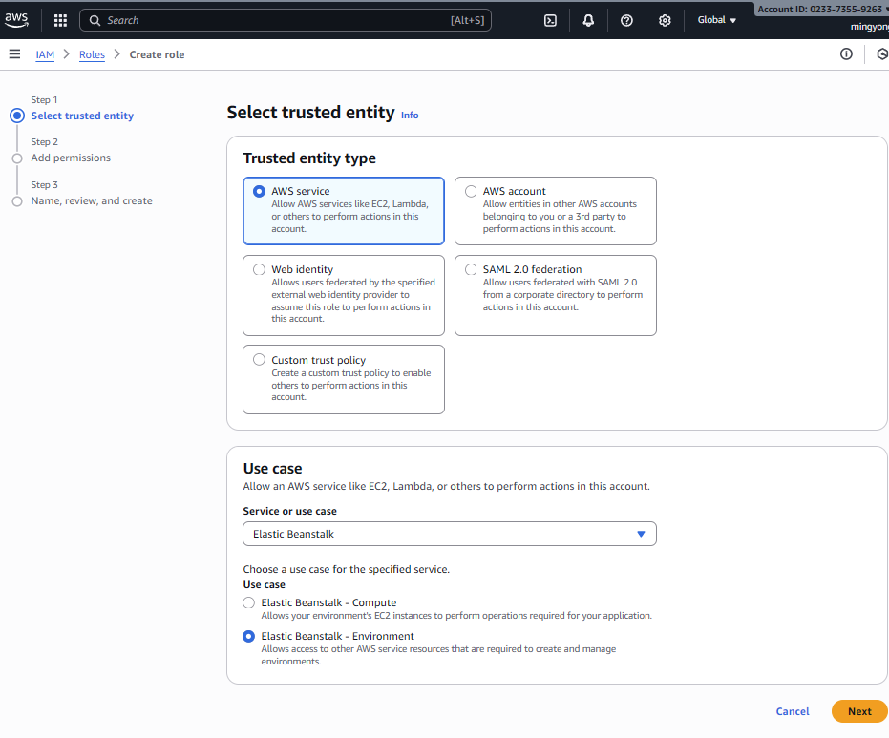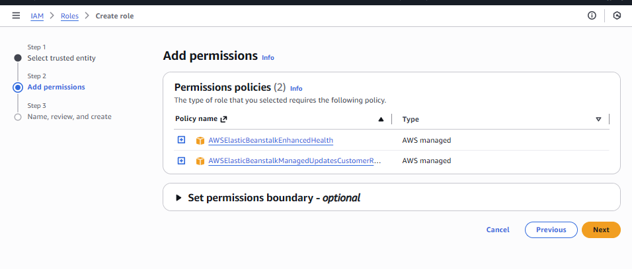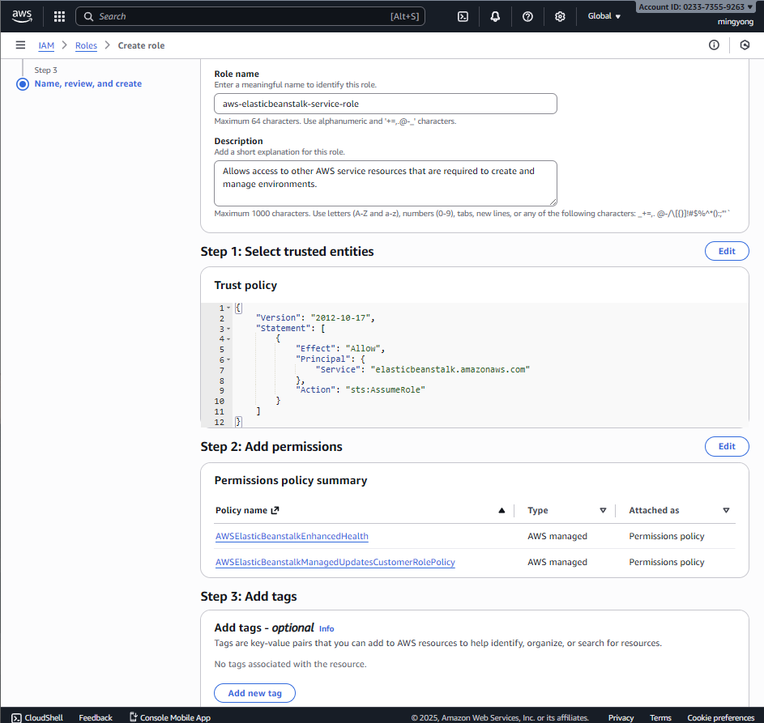

Create EC2 instance profile

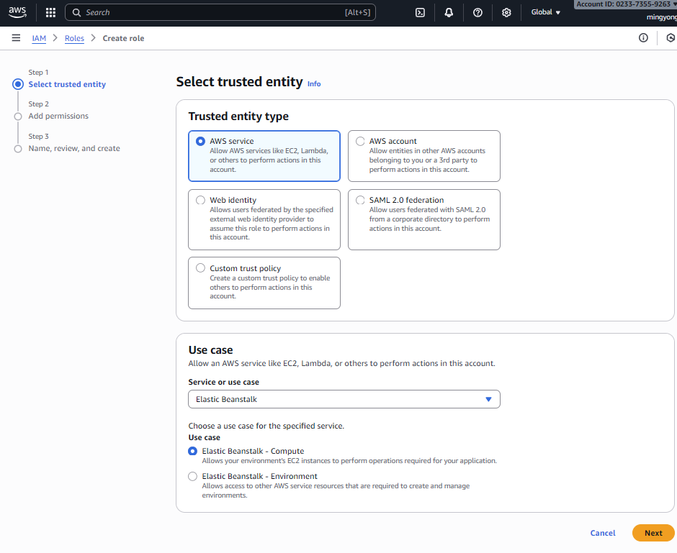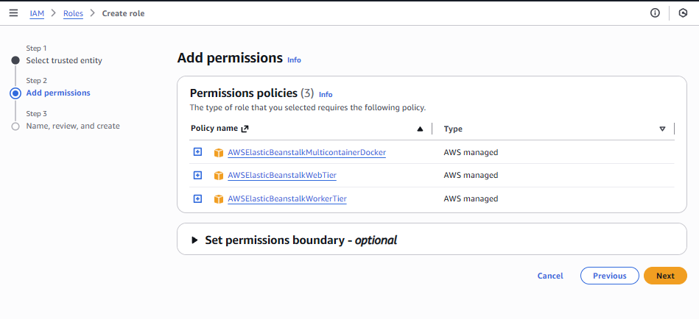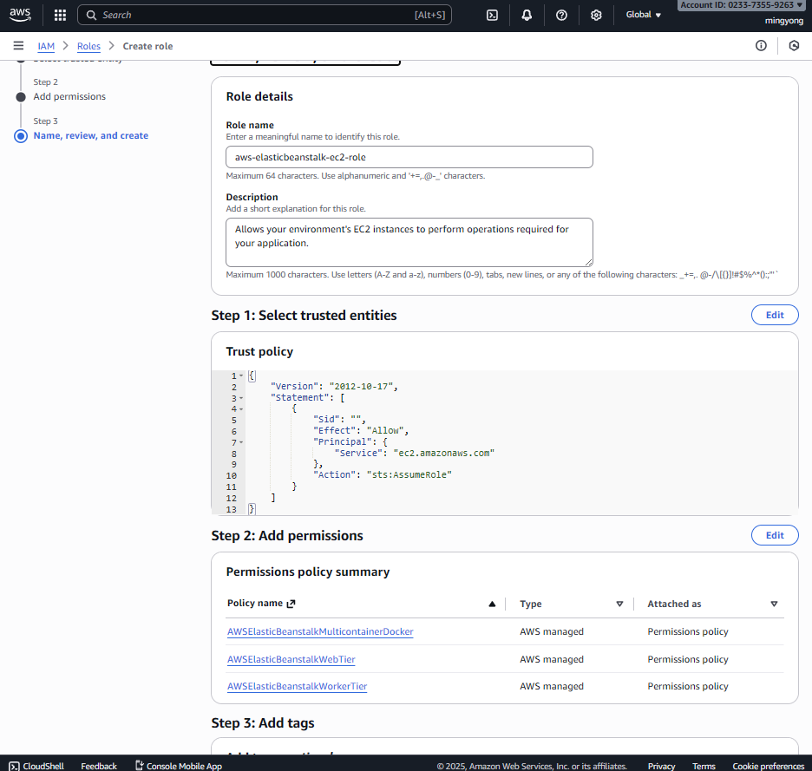

Deploy stage

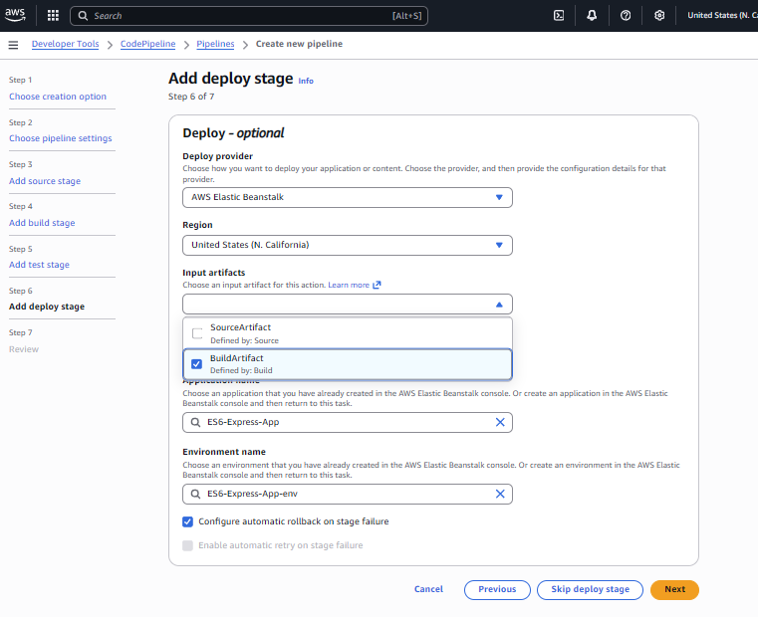

**IAM Fix:**

* Attached AWSElasticBeanstalkFullAccess to AWSCodePipelineServiceRole-us-west-1-ES6-Express-Pipelinev

{

"Version": "2012-10-17",

"Statement": [

{

"Effect": "Allow",

"Action": [

"elasticbeanstalk:*",

"ec2:Describe*",

"ec2:AuthorizeSecurityGroupIngress",

"ec2:RevokeSecurityGroupIngress",

"ec2:CreateSecurityGroup",

"ec2:DeleteSecurityGroup",

"autoscaling:Describe*",

"autoscaling:UpdateAutoScalingGroup",

"autoscaling:SuspendProcesses",

"autoscaling:ResumeProcesses",

"cloudformation:*",

"s3:PutObject",

"s3:GetObject",

"s3:ListBucket",

"logs:DescribeLogGroups",

"logs:CreateLogGroup",

"logs:PutRetentionPolicy"

],

"Resource": "*"

},

{

"Effect": "Allow",

"Action": "iam:PassRole",

"Resource": "*",

"Condition": {

"StringEquals": {

"iam:PassedToService": "elasticbeanstalk.amazonaws.com"

}

}

}

]

}

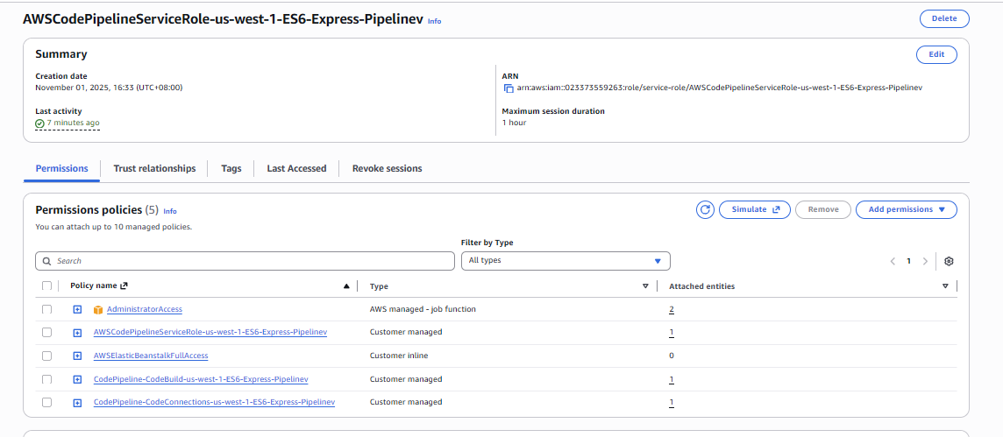

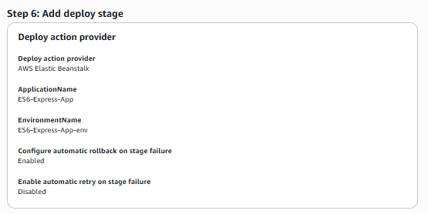

1. Put evidence in report that AWS Beanstalk application is successfully deployed and verify application reachable

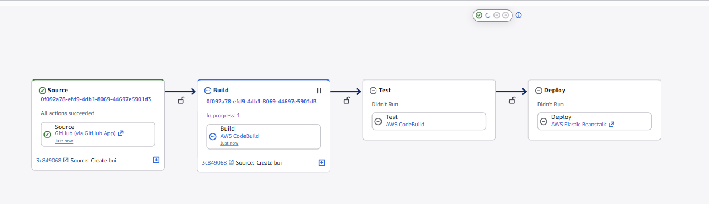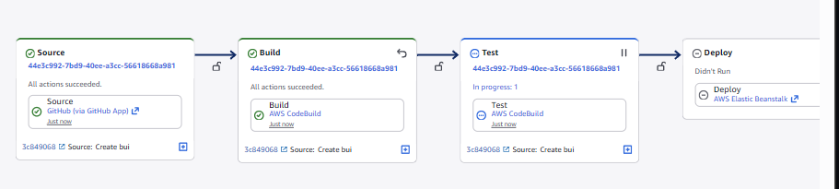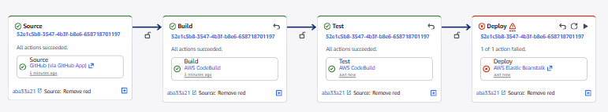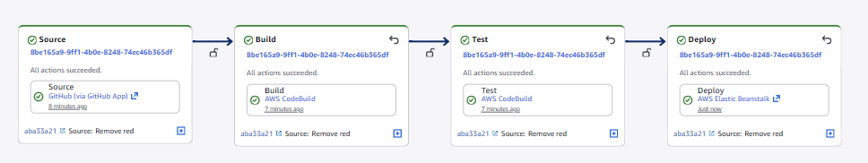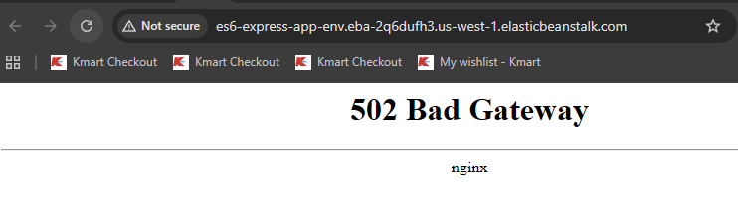

1. Modify the Application Code
   1. Modify the source code so that the text reads `My Student ID is xxxxxx. Welcome to Express` (replace the xxxxxx with your student Id). (Screenshot must be in the report).

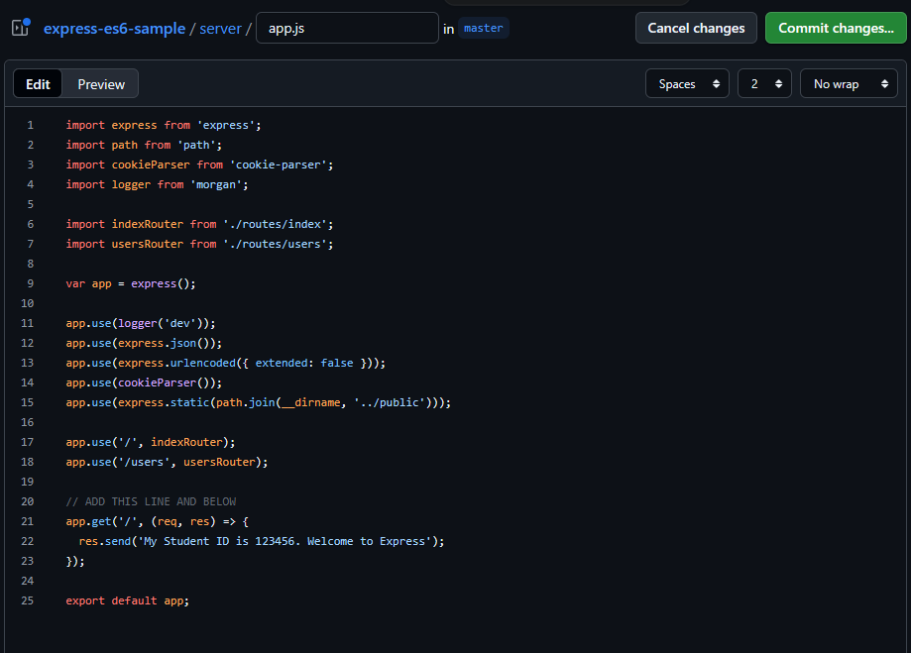

* 1. Push the code change to the forked repository.

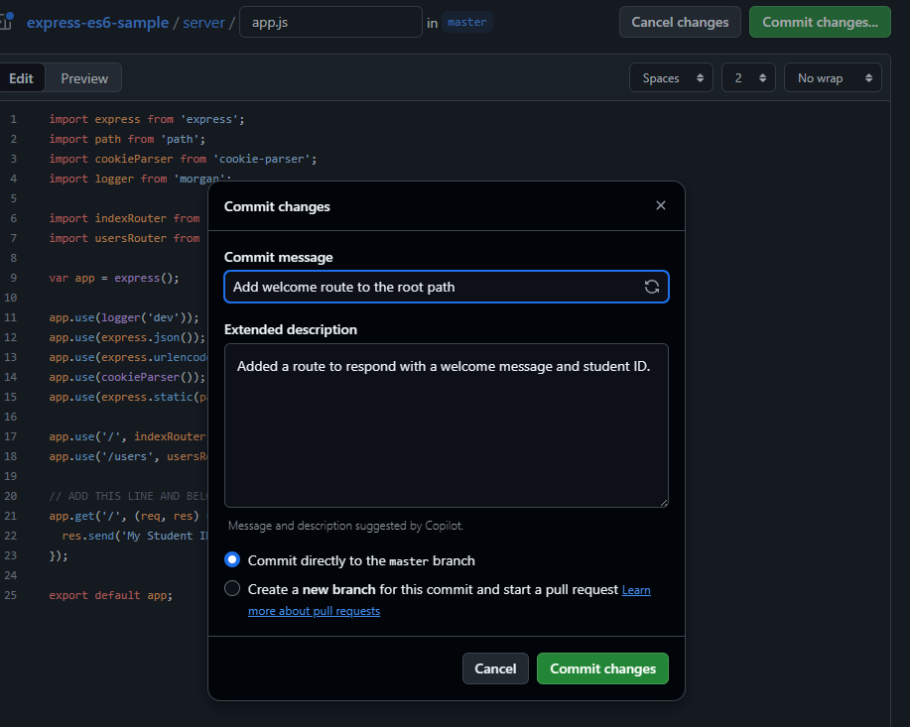

* 1. The pipeline should automatically detect the change, build, and deploy the updated application to AWS Beanstalk. (Check whether the automatic updating of the change is taking place or not).

Auto update.

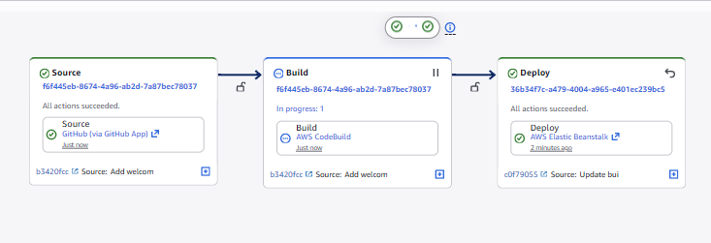

1. Create a Cross-Account IAM Role:

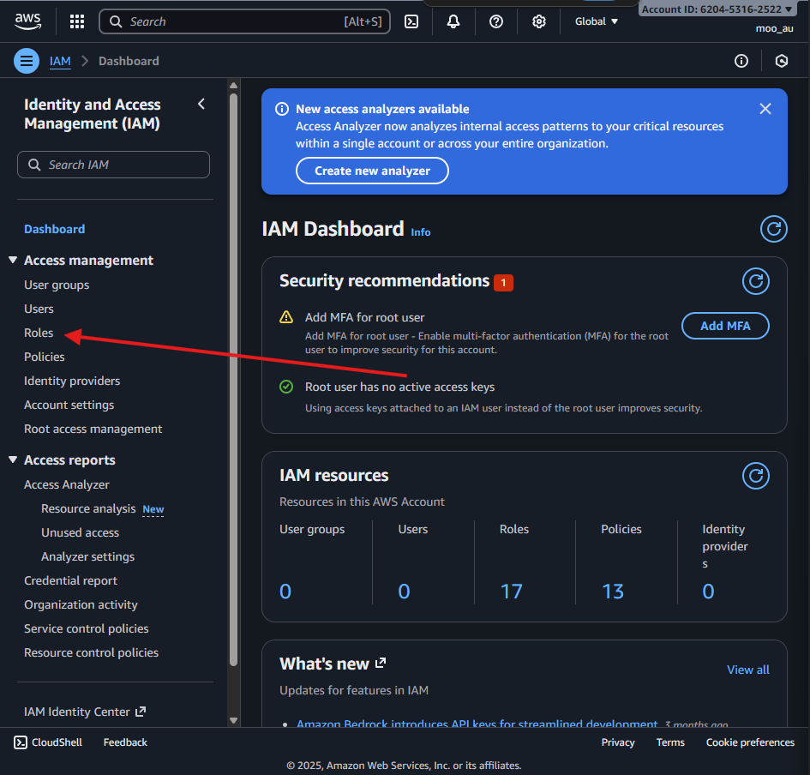

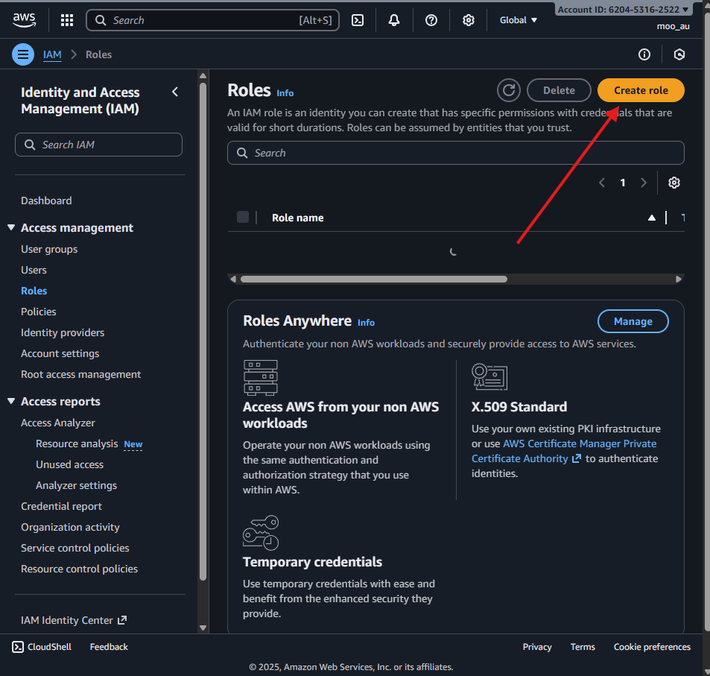

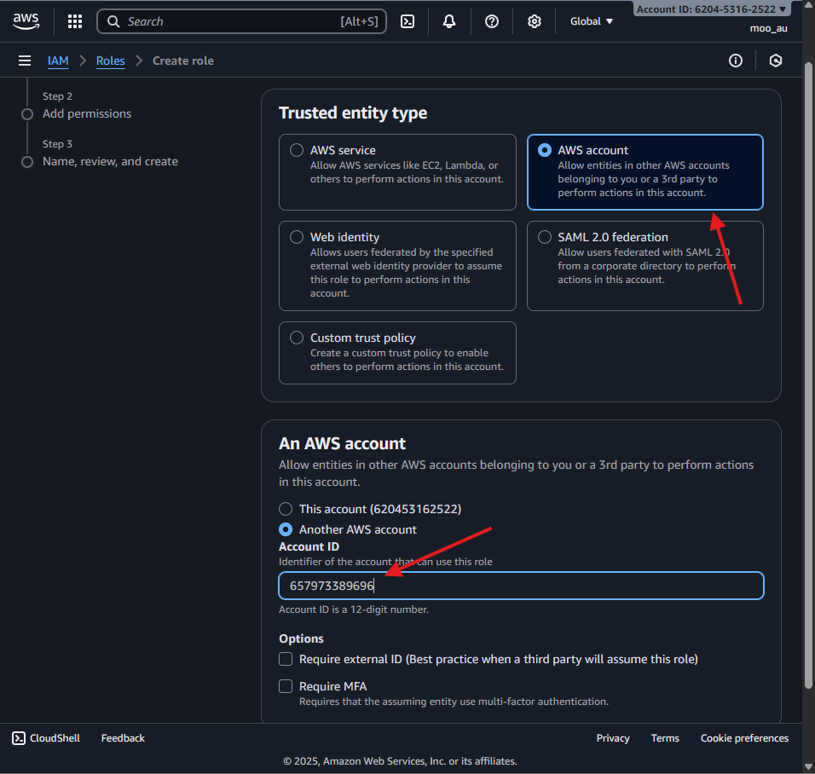

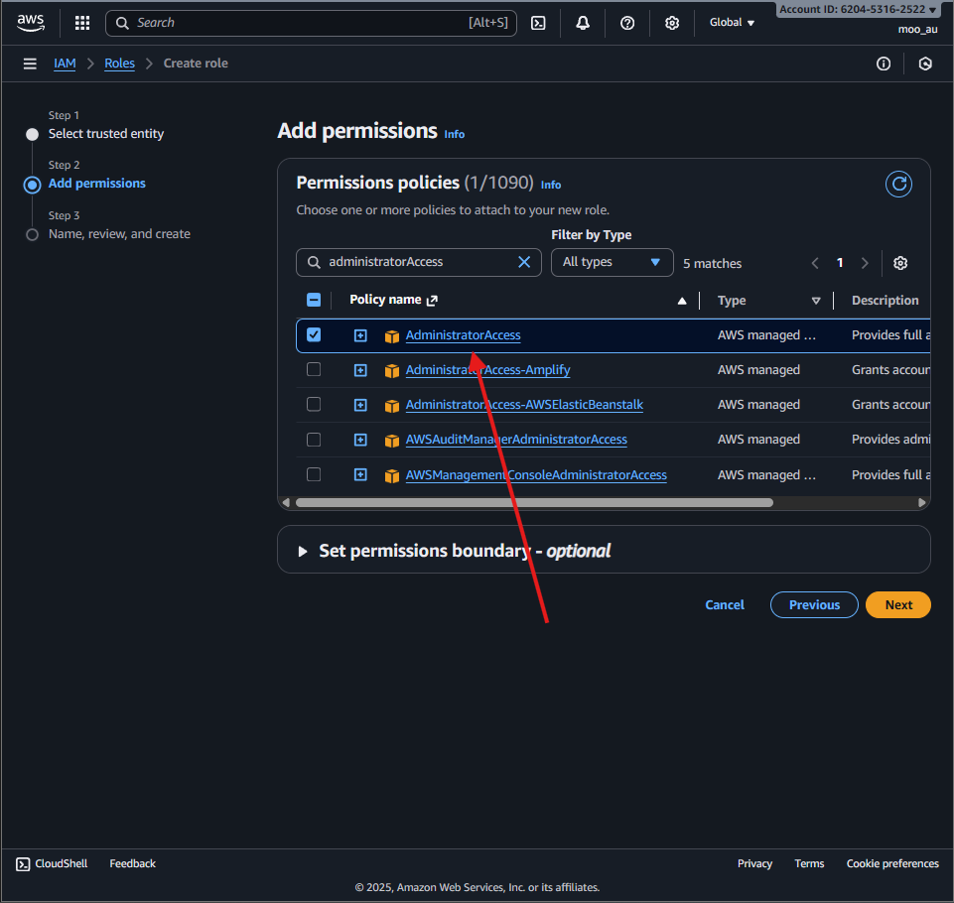

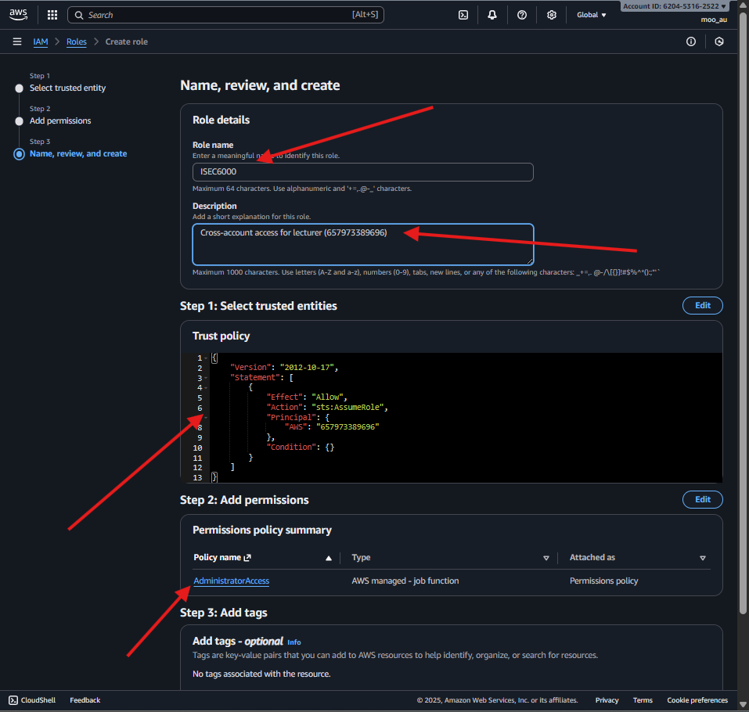

**Permissions:**

* AdministratorAccess (full access for review)

**Security Controls:**

* Access restricted to **one specific AWS account**
* Temporary credentials via sts:AssumeRole
* Role can be deleted after review

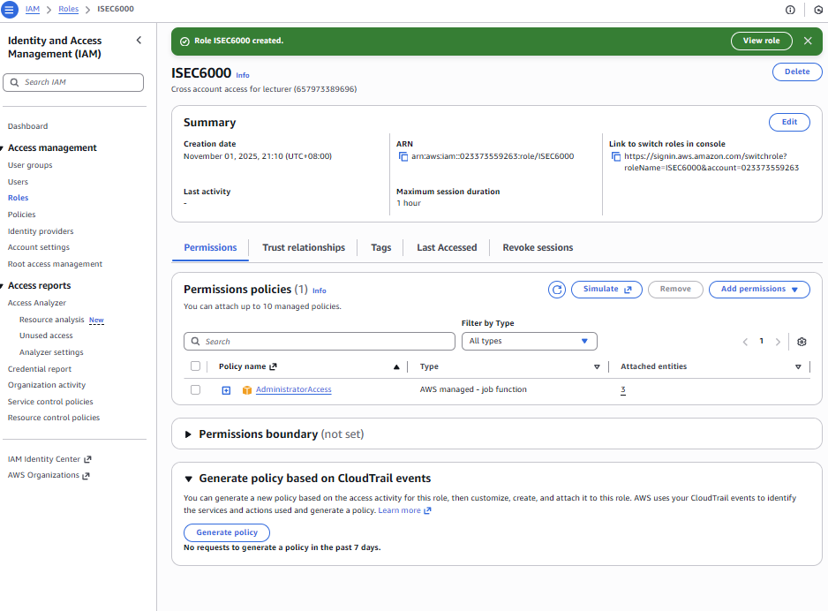

# Task 6: Threat Modelling using STRIDE

### Create a New Model:

[OWASP Threat Dragon](https://www.threatdragon.com/#/dashboard)

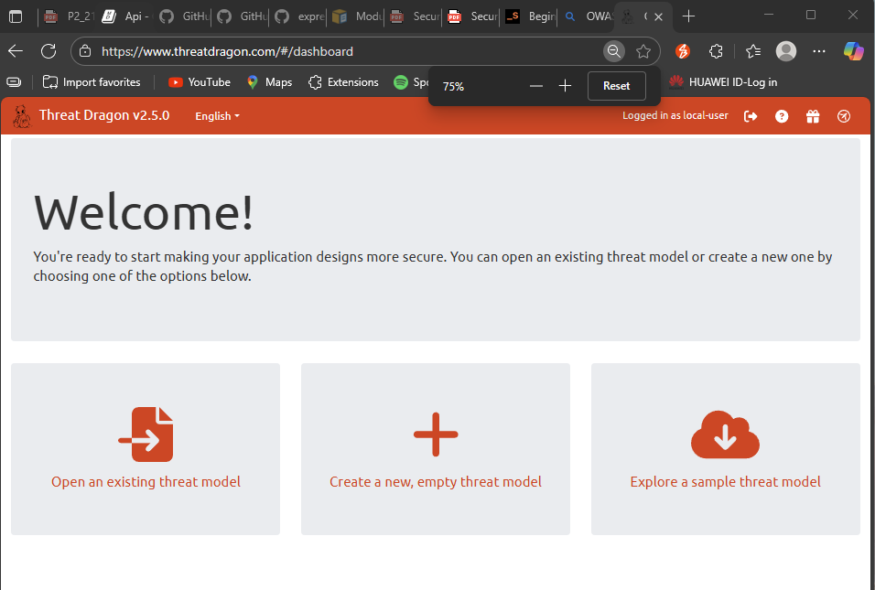

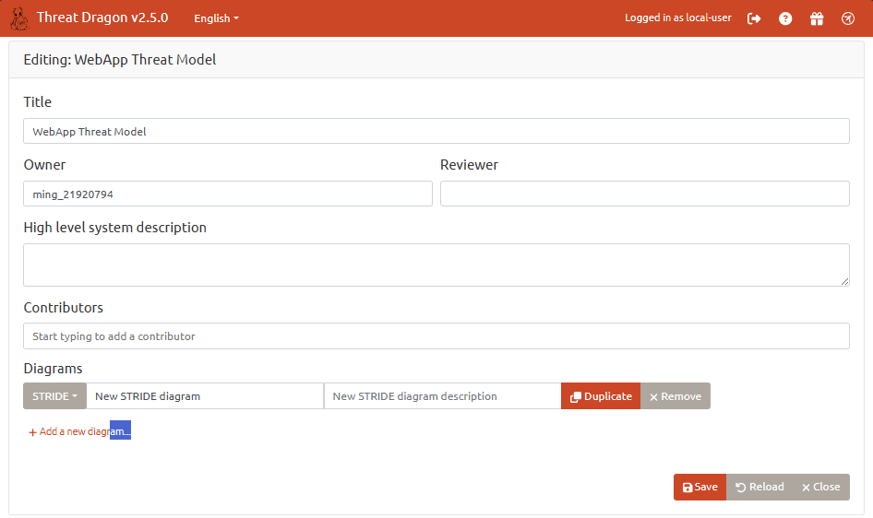

Click save and go back to the main page.

### Map the System Components:

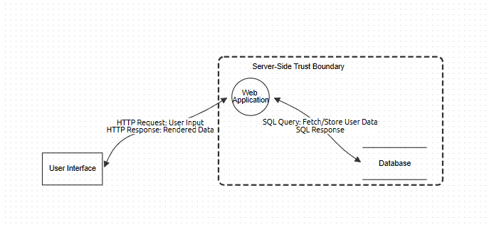

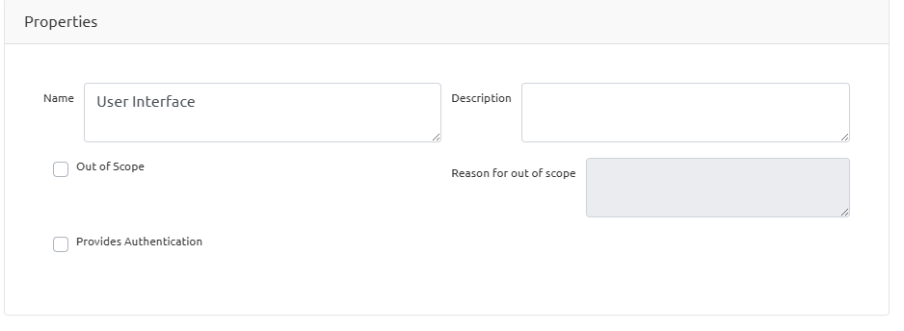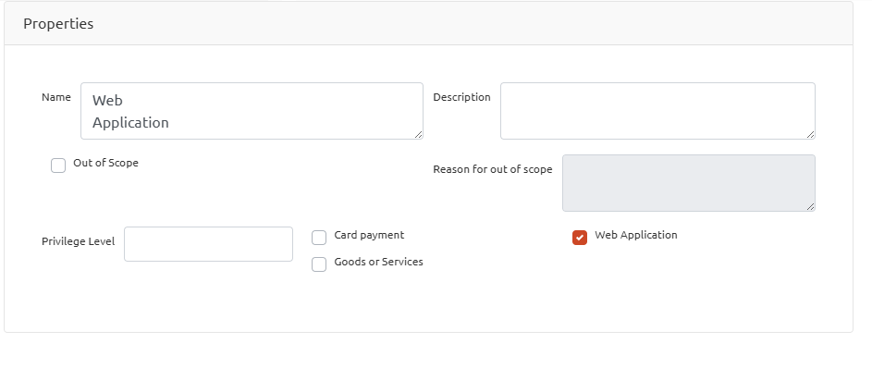

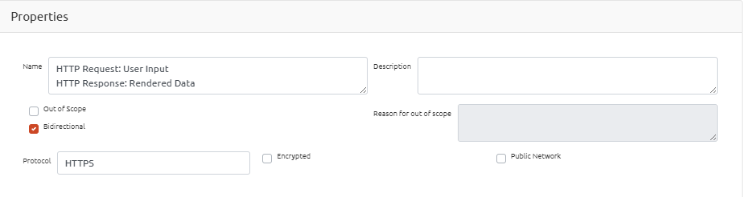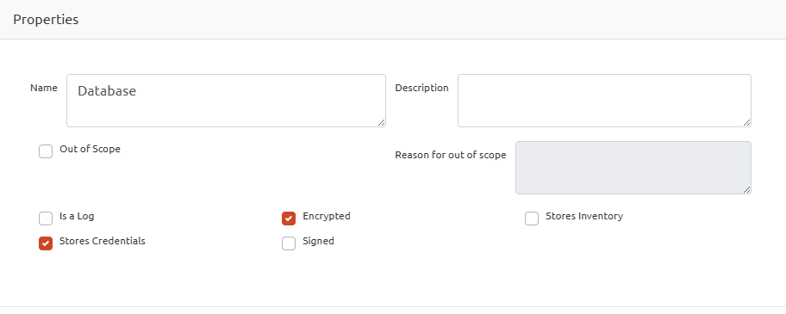

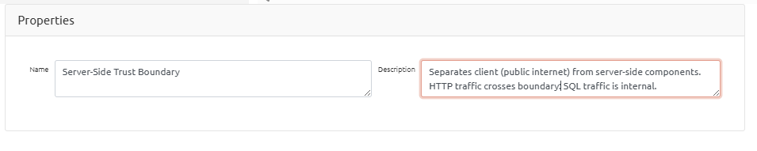

### Identify Threats Using STRIDE:

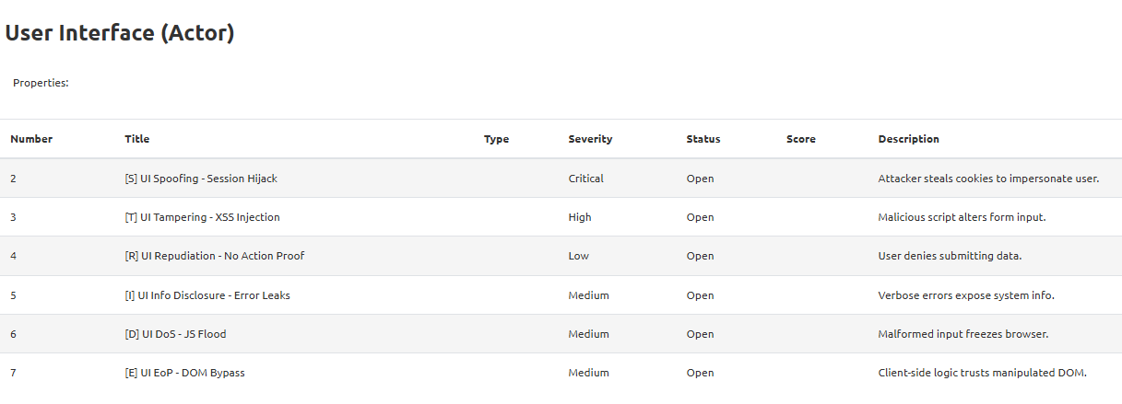

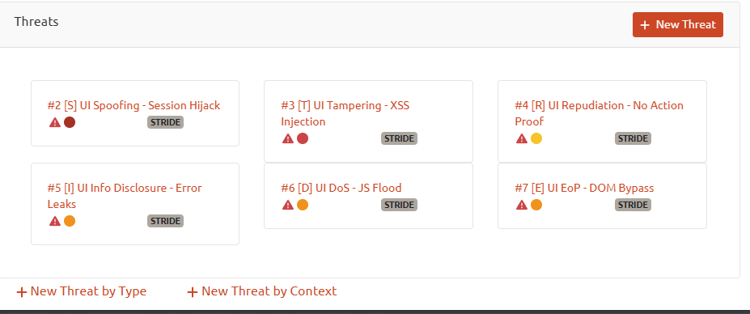

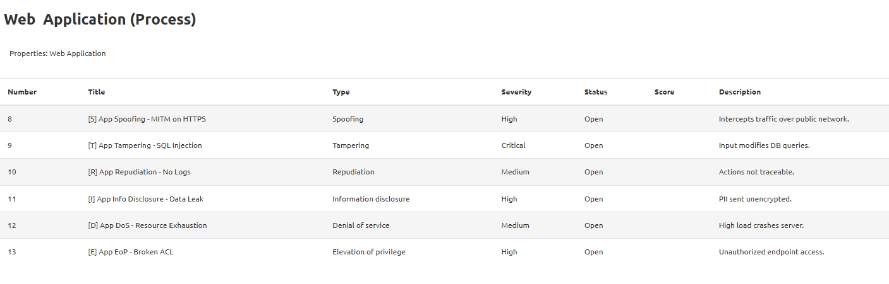

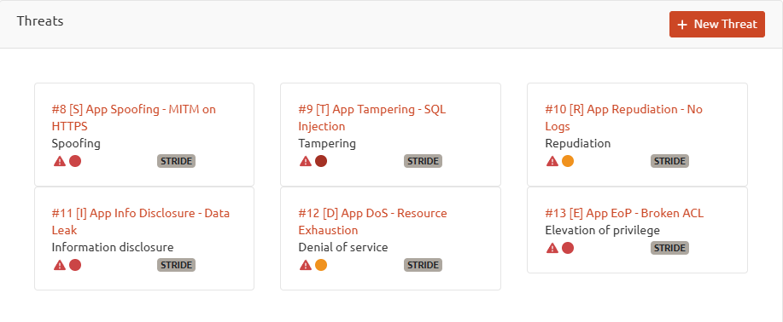

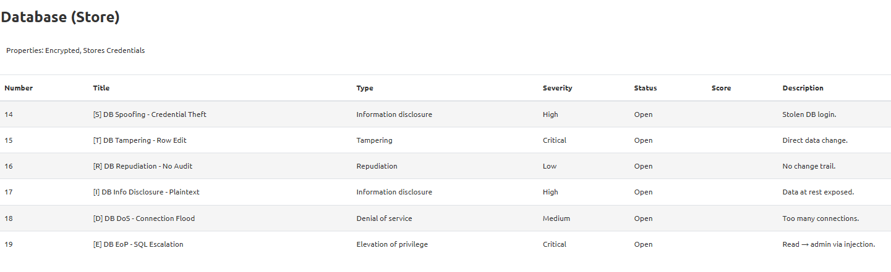

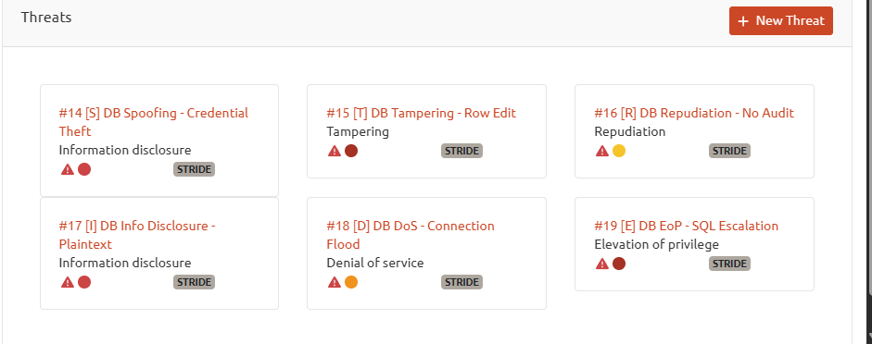

### Document and Mitigate Threats:

